

|  |  |  |
| --- | --- | --- |
| **Introduction to AI & ML** | | |
| Lab Manual | | |
| **Department of Computer Science and Engineering**  **The NorthCap University, Gurugram** | | |
|  | |
|  | |
|  | |
|  | |
|  |

**Introduction to AI &ML Lab Manual**

**CSL 236**



Department of Computer Science and Engineering

The NorthCap University, Gurugram- 122001, India

Session 2022-23

*Published by:*

**School of Engineering and Technology**

**Department of Computer Science & Engineering**

**The NorthCap University Gurugram**

**• Laboratory Manual is for Internal Circulation only**

**© Copyright Reserved**

*No part of this Practical Record Book may be*

*reproduced, used, stored without prior permission of The NorthCap University*



Copying or facilitating copying of lab work comes under cheating and is considered as use of unfair means. Students indulging in copying or facilitating copying shall be awarded zero marks for that particular experiment. Frequent cases of copying may lead to disciplinary action. Attendance in lab classes is mandatory.

Labs are open up to 7 PM upon request. Students are encouraged to make full use of labs beyond normal lab hours.

**PREFACE**

Machine Learning Lab Manual is designed to meet the course and program requirements of NCU curriculum for B.Tech. III year students of CSE branch. The concept of the lab work is to give brief practical experience for basic lab skills to students. It provides the space and scope for self-study so that students can come up with new and creative ideas.

The Lab manual is written on the basis of “teach yourself pattern” and expected that students who come with proper preparation should be able to perform the experiments without any difficulty. Brief introduction to each experiment with information about self-study material is provided. The pre-requisite is having a basic working knowledge of Python. The laboratory exercises will include familiarization with data pre-processing techniques for ML like handling missing data, duplicate data, outliers feature scaling and encoding. Feature Selection and Dimensionality Reduction are included to enhance the performance and reduce the computational time. Various ML classification and regression techniques are taught. Students would learn the algorithms pertaining to these and implement the same using a high-level language, i.e. Python. Students are expected to come thoroughly prepared for the lab. General disciplines, safety guidelines and report writing are also discussed.

The lab manual is a part of curriculum for the The NorthCap University, Gurugram. Teacher’s copy of the experimental results and answer for the questions are available as sample guidelines.

We hope that lab manual would be useful to students of CSE, IT, ECE and BSc branches and author requests the readers to kindly forward their suggestions / constructive criticism for further improvement of the work book.

Author expresses deep gratitude to Members, Governing Body-NCU for encouragement and motivation.

**Authors**

**The NorthCap University**

**Gurugram, India**

|  |  |  |
| --- | --- | --- |
| **CONTENTS** | | |
| S.N. | **Details** | Page No. |
|  | **Syllabus** | 6 |
| 1 | **Introduction** | 9 |
| 2 | **Lab Requirement** | 10 |
| 3 | **General Instructions** | 11 |
| 4 | **List of Experiments** | 13 |
| 5 | **List of Flip Assignment** | 14 |
| 6 | **List of Projects** | 15 |
| 7 | **Rubrics** | 16 |
| 8 | **Annexure 1 (Format of Lab Report)** | 18 |

**SYLLABUS**

|  |  |  |  |  |  |  |  |  |  |
| --- | --- | --- | --- | --- | --- | --- | --- | --- | --- |
| 1. **Department:** | | | Department of Computer Science and Engineering | | | | | | |
| 1. **Course Name: Machine Learning** | | | | | 1. **Course Code** | 1. **L-T-P** | | | 1. **Credits** |
| CSL236 | 3-0-2 | | | 4 |
| 1. **Type of Course (Check one):** | | | Program Core **✔**  Program Elective Open Elective | | | | | | |
| 1. **Pre-requisite(s), if any:** Introduction to AI and ML | | | | | | | | | |
| 1. **Frequency of offering (check one):** Odd **✔** Even Either semester Every semester | | | | | | | | | |
| 1. **Brief Syllabus:**   Introduction to artificial intelligence, History of AI, Proposing and evaluating AI application, Preprocessing and Feature Engineering, Case study: Exploratory Analysis of Delhi Pollution, Simple Linear Regression, Multiple Regression, Polynomial Regression, Support Vector Regression SVR, Decision Tree Regression, Random Forest Regression, Logistic Regression, K Nearest Neighbors, Support Vector Machine, Kernel SVM, Naïve Bayes, Decision Trees Classification, Random Forest Classification, Basic Terminologies: Overfitting, Underfitting, Bias and Variance model, Bootstrapping, Cross-Validation and Resampling Methods, Performance Measures: Confusion matrix, ROC. Comparing two classification Algorithms:  McNamara’s Test, paired t-test. | | | | | | | | | |
| **Total lecture, Tutorial and Practical Hours for this course (Take 15 teaching weeks per semester): 75** hours  The class size is maximum 30 learners | | | | | | | | | |
| **Lectures: 40** hours | | | | **Practice** | | | | | |
| **Tutorials:** 0 hours | | | **Lab Work: 35** hours | | |
| 1. **Course Outcomes (COs)**   On successful completion of this course students will be able to: | | | | | | | | | |
| **CO 1** | Understand and implement the preprocessing of the data to be used for machine learning models. | | | | | | | | |
| **CO 2** | Understand the strengths and limitations of various ML algorithms. | | | | | | | | |
| **CO 3** | Understand why models degrade and how to maintain them. | | | | | | | | |
| **CO 4** | Implement and use model grading metrics. | | | | | | | | |
| **CO 5** | Apply ML techniques and technologies to solve real world business problems. | | | | | | | | |
| 1. **UNIT WISE DETAILS No. of Units: 5** | | | | | | | | | |
| **Unit Number: 1** | | **Title: Introduction to AI and ML** | | | | | | **No. of hours: 4** | |
| **Content Summary:**  Introduction to artificial intelligence, History of AI, Overview of machine learning, techniques in machine learning, deep learning, differences between deep learning, machine learning and AI, different applications of machine learning, different types of data. | | | | | | | | | |
| **Unit Number: 2** | | **Data preprocessing and engineering** | | | | | | **No. of hours:10** | |
| Content Summary:  Introduction to Data Preprocessing, different preprocessing techniques, data cleaning, data transformation: standardization and normalization, data smoothing, dimensionality reduction, different encoding schemes for categorical and numerical features. | | | | | | | | | |
| **Unit Number: 3** | | **Title: Regression Techniques** | | | | | | **No. of hours:12** | |
| **Content Summary:**  Simple Linear Regression, Multiple Regression, Polynomial Regression, Support Vector Regression SVR, Decision Tree Regression, Random Forest Regression | | | | | | | | | |
| **Unit Number: 4** | | **Title: Classification algorithm techniques** | | | | | | **No. of hours:12** | |
| Logistic Regression, K Nearest Neighbors, Support Vector Machine, Kernel SVM, Naïve Bayes, Decision Trees Classification, Random Forest Classification | | | | | | | | | |
| **Unit Number: 5** | | **Title: Analysis of various algorithms** | | | | | | **No. of hours:7** | |
| Basic Terminologies: Over fitting, Under fitting, Bias and Variance model, Bootstrapping, Cross-Validation and Resampling Methods, Performance Measures: Confusion matrix, ROC. | | | | | | | | | |
| 1. **Brief Description of Self-learning components by students (through books/resource material etc.):**   Data-preprocessing techniques | | | | | | | | | |
| **13. Advance Learning Components:**  Probability and Statistics and Linear Algebra | | | | | | | | | |
| **14. Books Recommended :**  **Text Books:**  1. Michael Bowles, “Machine Learning in Python ” Wiley, Third Edition, 2019  2. Jiawei Han, Micheline Kamber and Jian Pei. Data Mining: Concepts and Techniques, 3rd ed.  **Reference Books:**  1. Ian H. Witten & Eibe Frank., “Data Mining Practical Machine Learning Tools and Techniques”, Morgan Kauffmann Publishers, Second Edition, 2020  2. Ethem Alpaydin, “Introduction to Machine Learning”, MIT Press, Third Edition, 2015  3. Tom Mitchell. Machine Learning. Mc Graw Hill  **Reference Websites: (NPTEL, Swayam, Coursera, Edx, Udemy, LMS, official documentation weblink)**   * [**https://nculms.ncuindia.edu/**](https://nculms.ncuindia.edu/) * [**https://www.simplilearn.com/big-data-and-analytics/machine-learning-certification-training-course**](https://www.simplilearn.com/big-data-and-analytics/machine-learning-certification-training-course) * [**https://www.coursera.org/learn/machine-learning**](https://www.coursera.org/learn/machine-learning) | | | | | | | | | |

**Faculty teaching the Course:**

Dr. Meghna Sharma

Dr. Vidhi Khanduja

Dr. Sujata

Dr. Shraddha Arora

Dr. Meenakshi

Ms. Ruchika Lalit

Dr. Anshul Bhatia

Dr. Nidhi Malik

1. **INTRODUCTION**

That ‘learning is a continuous process’ cannot be over emphasized. The theoretical knowledge gained during lecture sessions need to be strengthened through practical experimentation. Thus, practical makes an integral part of a learning process.

**OBJECTIVES:**

The purpose of conducting experiments can be stated as follows:

* To familiarize the students with the basic concepts of Machine Learning like supervised, unsupervised and reinforcement learning.
* The lab sessions will be based on exploring the concepts discussed in class.
* Learning and understanding Data Preprocessing techniques.
* Learning and understanding regression and classification problems and algorithms.
* Learning and understanding Feature selection and Dimensionality Reduction.
* Learning and understanding performance metrics.
* Hands on experience

1. **LAB REQUIREMENTS**

|  |  |  |
| --- | --- | --- |
| **S.No.** | **Requirements** | **Details** |
| **1** | **Software Requirements** | Python 3. |
| **2** | **Operating System** | Windows(64-bit), Linux |
| **3** | **Hardware Requirements** | 8 GB RAM (Recommended)  2.60 GHz (Recommended) |
| **4** | **Required Bandwidth** | NA |

1. **GENERAL INSTRUCTIONS** 
   1. **General discipline in the lab**
   * Students must turn up in time and contact concerned faculty for the experiment they are supposed to perform.
   * Students will not be allowed to enter late in the lab.
   * Students will not leave the class till the period is over.
   * Students should come prepared for their experiment.
   * Experimental results should be entered in the lab report format and certified/signed by concerned faculty/ lab Instructor.
   * Students must get the connection of the hardware setup verified before switching on the power supply.
   * Students should maintain silence while performing the experiments. If any necessity arises for discussion amongst them, they should discuss with a very low pitch without disturbing the adjacent groups.
   * Violating the above code of conduct may attract disciplinary action.
   * Damaging lab equipment or removing any component from the lab may invite penalties and strict disciplinary action.
   1. **Attendance**

* Attendance in the lab class is compulsory.
* Students should not attend a different lab group/section other than the one assigned at the beginning of the session.
* On account of illness or some family problems, if a student misses his/her lab classes, he/she may be assigned a different group to make up the losses in consultation with the concerned faculty / lab instructor. Or he/she may work in the lab during spare/extra hours to complete the experiment. No attendance will be granted for such case**.**
  1. **Preparation and Performance**
* Students should come to the lab thoroughly prepared on the experiments they are assigned to perform on that day. Brief introduction to each experiment with information about self study reference is provided on LMS.
* Students must bring the lab report during each practical class with written records of the last experiments performed complete in all respect.
* Each student is required to write a complete report of the experiment he has performed and bring to lab class for evaluation in the next working lab. Sufficient space in work book is provided for independent writing of theory, observation, calculation and conclusion.
* Students should follow the Zero tolerance policy for copying / plagiarism. Zero marks will be awarded if found copied. If caught further, it will lead to disciplinary action.
* Refer **Annexure 1** for Lab Report Format

1. **LIST OF EXPERIMENTS**

|  |  |  |  |  |  |
| --- | --- | --- | --- | --- | --- |
| **Sr. No.** | **Title of the Experiment** | **Software**  **used** | **Unit**  **Covered** | **CO**  **Covered** | **Time**  **Required** |
| **1** | To introduce various python libraries used for machine learning. | Python  (Jupyter) | 1 | CO1 | 4 hours |
| 2 | To apply various data pre-processing techniques used for effective machine learning on the given dataset. | Python  (Jupyter) | 1 | CO1 | 2 hours |
| 3 | To apply feature encoding schemes such as label encoder and onehotencoder. | Python  (Jupyter) | 1 | CO1 | 3 hours |
| 4 | To apply different feature selection techniques in machine learning. | Python  (Jupyter) | 1 | CO1 | 3 hours |
| 5 | To apply PCA as feature reduction technique on IRIS dataset. | Python  (Jupyter) | 2 | CO1 | 2 hours |
| 6 | To apply Simple Linear Regression on the given dataset. | Python  (Jupyter) | 2 | CO2, CO3, CO4 | 2 hours |
| 7 | To apply multiple linear regression on any regression dataset. | Python  (Jupyter) | 2 | CO2, CO3, CO4 | 3 hours |
| 8 | To apply Polynomial Linear Regression on the given dataset. | Python  (Jupyter) | 2 | CO2, CO3, CO4 | 3 hours |
| 9 | To solve classification problems using Logistic Regression. | Python  (Jupyter) | 3 | CO2, CO3, CO4 | 2 hours |
| 10 | To solve classification problems using KNN classification. | Python  (Jupyter) | 3 | CO2, CO3, CO4 | 2 hours |
| 11 | To solve classification problems using Naïve Bayes. | Python  (Jupyter) | 4 | CO2, CO3, CO4 | 2 hours |
| 12 | To apply Support Vector Machines (SVM) on classification problems. | Python  (Jupyter) | 4 | CO2, CO3, CO4 | 3 hours |
| 13 | To apply Decision Trees for classification problems. | Python  (Jupyter) | 4 | CO2, CO3, CO4 | 3 hours |
| **Value Added Experiments** | | | | | |
| 14 | Build a ML model from scratch using data-preprocessing and regression algorithms and calculating various performance metrics. | Python  (Jupyter) | 1,2,3,4 | CO1,CO2,  CO3,CO4,CO5 | 5 hours |
| 15 | Build a ML model from scratch using data-preprocessing and classification algorithms and calculating various performance metrics. | Python  (Jupyter) | 1,2,3,4 | CO1,CO2,  CO3,CO4,CO5 | 5 hours |

1. **LIST OF FLIP EXPERIMENTS**
   1. Project – Dimensionality reduction using LDA.

5.2 Competition on Kaggle

1. **LIST OF PROJECTS**
   * + 1. Titanic Challenge: The sinking of the Titanic is one of the most infamous shipwrecks in history.On April 15, 1912, during her maiden voyage, the widely considered “unsinkable” RMS Titanic sank after colliding with an iceberg. Unfortunately, there weren’t enough lifeboats for everyone onboard, resulting in the death of 1502 out of 2224 passengers and crew.While there was some element of luck involved in surviving, it seems some groups of people were more likely to survive than others.In this project, the students need to build a predictive model that answers the question: “what sorts of people were more likely to survive?” using passenger data (ie name, age, gender, socio-economic class, etc)*.*
       2. House Price Prediction Using Advanced Regression Techniques: Ask a home buyer to describe their dream house, and they probably won't begin with the height of the basement ceiling or the proximity to an east-west railroad. But Kaggle’s advanced house price prediction dataset proves that much more influences price negotiations than the number of bedrooms or a white-picket fence. With 79 explanatory variables describing (almost) every aspect of residential homes in Ames, Iowa, this dataset can be used to predict the final price of each home.
       3. Mechanism of Action (MoA) Prediction: Mechanism of action means the biochemical interactions through which a drug generates its pharmacological effect.  If we know a disease affects some particular receptor or downstream set of cell activity, we can develop drugs faster if we can predict how cells and genes affect various receptor sites.  Using a dataset that combines gene expression and cell viability data in addition to the MoA annotations of more than 5,000 drugs.  In this, each drug was tested under two dose (cp_dose) and three times (cp_time). So, six samples basically correspond to one drug.  We need to train a model that classifies drugs based on their biological activity.  This problem is a multi-label classification, which means we have multiple targets (not multiple classes).  In this project, perform explanatory data analysis and then train a model using deep neural networks with Keras.
2. **RUBRICS**

|  |  |
| --- | --- |
| **Marks Distribution** | |
| **Continuous Evaluation (30 Marks)** | **Project Evaluations (40 Marks)** |
| Each experiment shall be evaluated for 10 marks and at the end of the semester proportional marks shall be awarded out of total 10. | Both the projects shall be evaluated for 40 marks each and at the end of the semester viva will be conducted related to the projects as well as concepts learned in labs and this component carries 40 marks. |
| **15 Marks:** For viva  **5 Marks:** MOOC |

**Annexure 1**

**Introduction to AI and ML**

**(CSL 236)**

**Lab Practical Report**



Faculty name: Dr. Sujata Student name: Arjun Bhardwaj

Roll No.: 21CSU211

Semester: V

Group: FS-V-A

**Department of Computer Science and Engineering**

**NorthCap University, Gurugram- 122001, India**

**Session 2022-23**

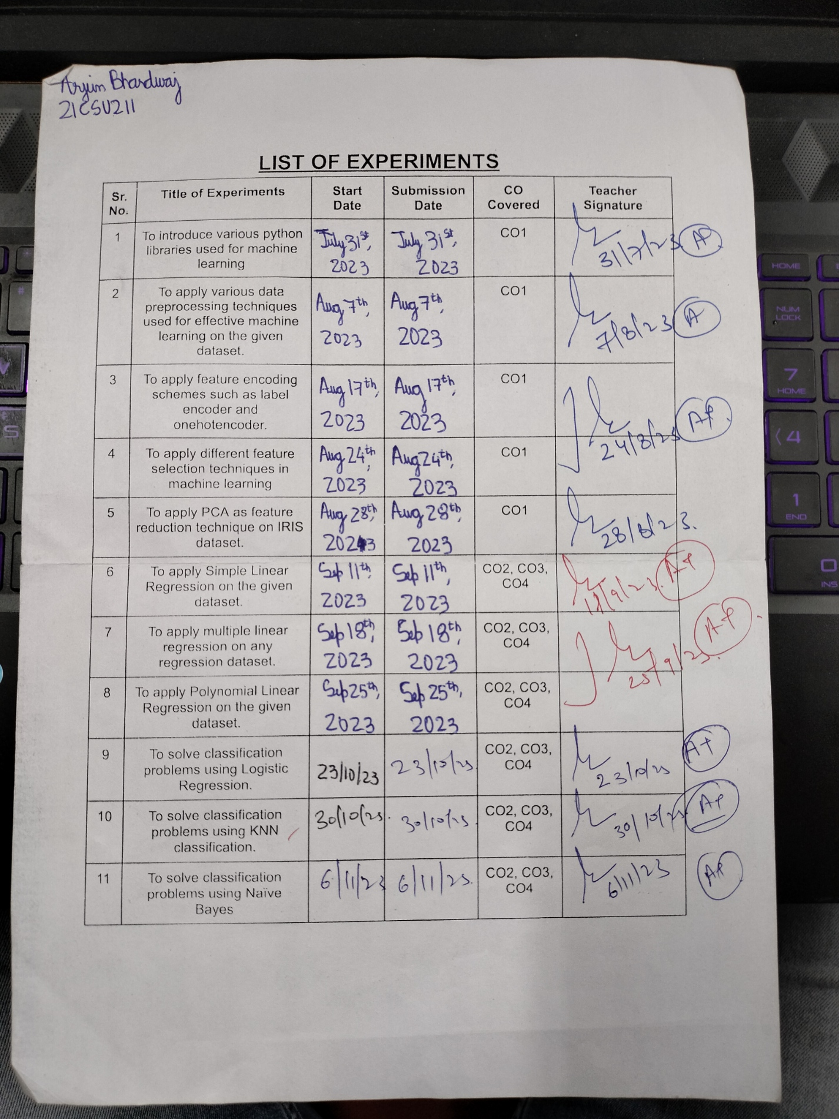

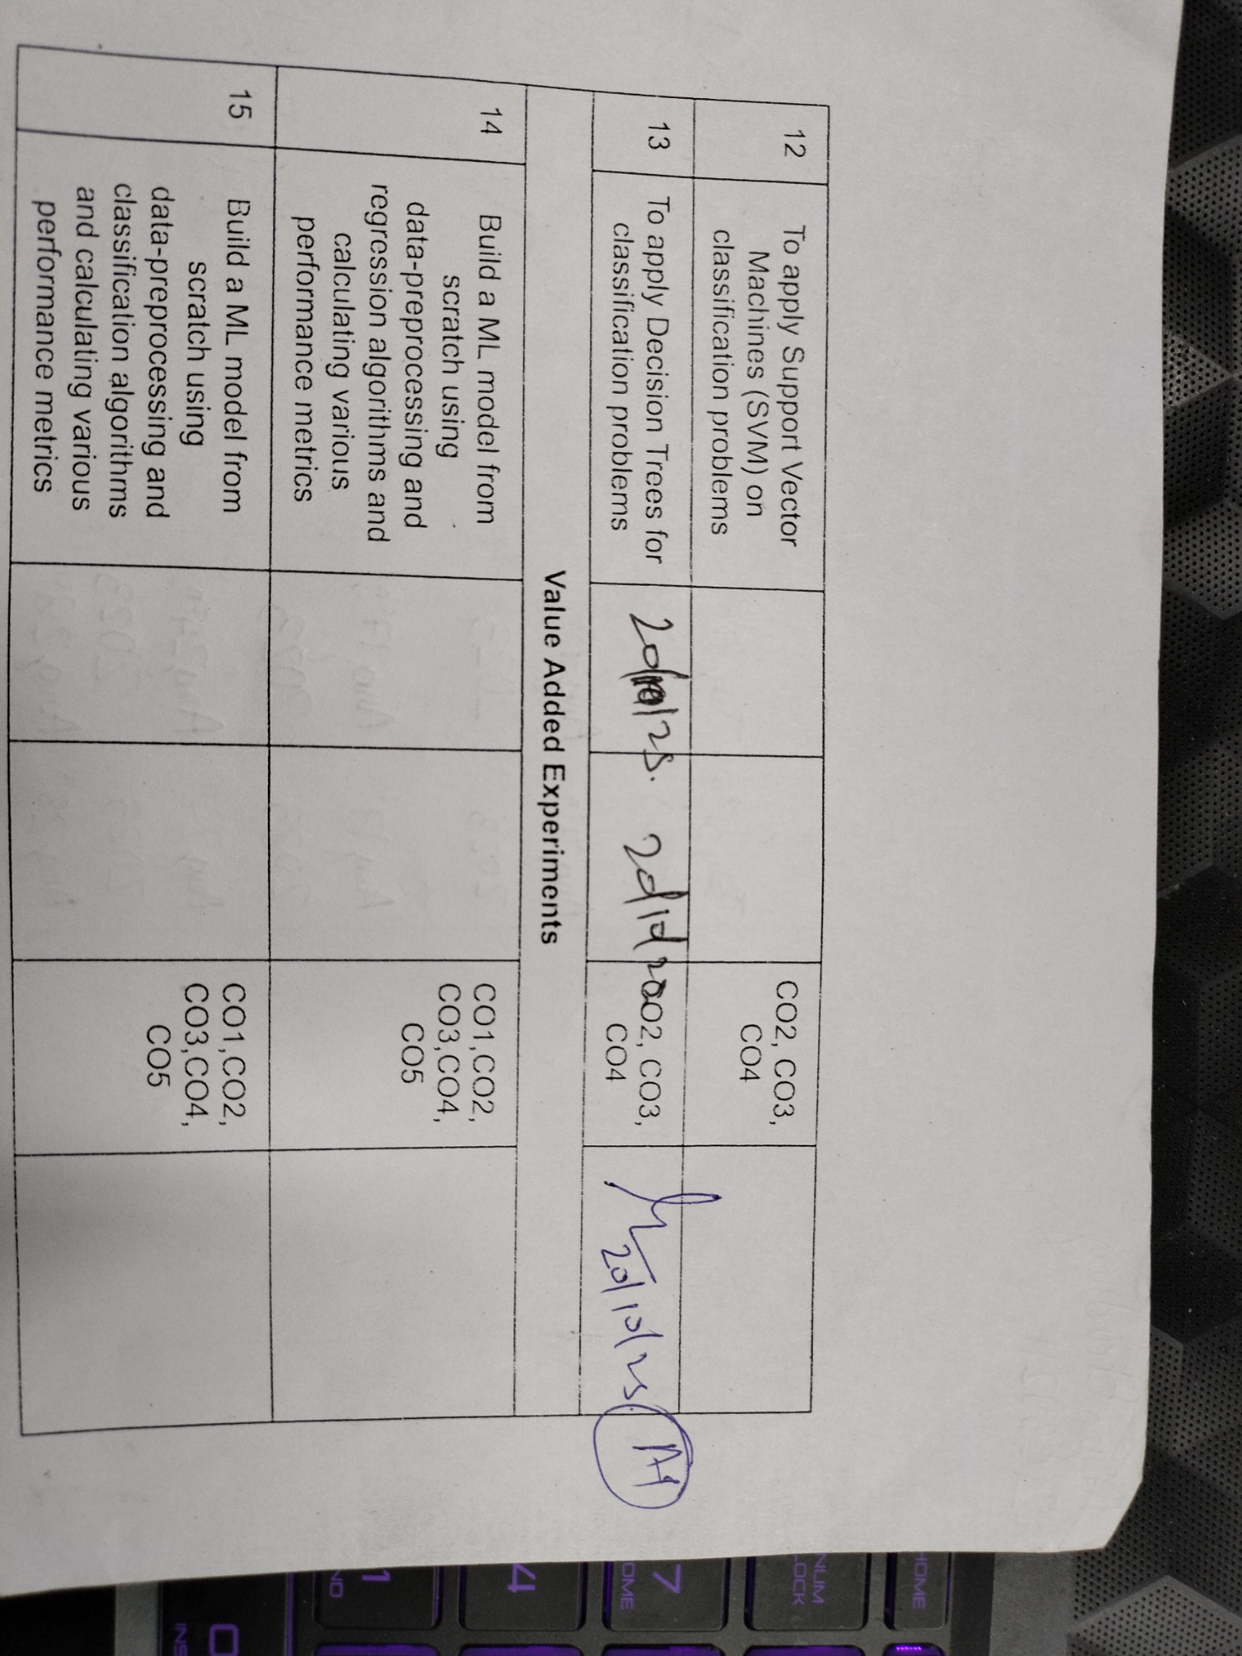

**EXPERIMENT NO. 1**

|  |
| --- |
| **Student Name and Roll Number:** Arjun Bhardwaj 21csu211 |
| **Semester /Section: FS-V-A** |
| **Link to Code:** |
| **Date: July 31th 2023** |
| **Faculty Signature:** |
| **Grade:** |

|  |
| --- |
| **Objective(s):**   * To understand the basic libraries of python. * To differentiate between numpy and pandas. |
| **Outcome:**  Students will be familiarized with handling dataset using python basic libraries and applying various operations on dataset using these. |
| **Problem Statement:**  To introduce various libraries of python used for machine learning. |
| **Background Study:**  **Basic libraries** of python are necessary to import datasets and applying various data pre-processing and machine learning techniques on them. |
| **Question Bank:**  1. How pandas can be used to read data from internet and from your system?  **from internet: pandas.read_csv('URL')  from your system: pandas.read_csv('file_path')**   1. How pandas dataframe can be converted to numpy arrays and vice versa?   **Pandas DataFrame to a NumPy array: df.to_numpy()**  **NumPy array to a Pandas DataFrame: pandas.DataFrame(array)**  3. How to access different rows and columns using loc and iloc?  **df.loc[row_labels, col_labels]**  **df.iloc[row_indices, col_indices]**  1. Differentiate between Feature Selection and Dimensionality Reduction.  Feature Selection: Involves choosing a subset of relevant features from the original set to improve model performance and interpretability.  Dimensionality Reduction: Focuses on transforming features into a lower-dimensional space for purposes like visualization and computational efficiency.  2. What are the advantages of Wrapper methods over filter methods for feature selection?  Wrapper methods for feature selection have the advantage of considering feature interactions, optimizing model performance, and adapting to different models. However, they are computationally expensive and may be prone to overfitting and high variance. The choice between wrapper and filter methods depends on your specific needs and computational resources.  3. Explain Regularization methods for Feature Selection.  Regularization methods like L1 (Lasso) and L2 (Ridge) add penalty terms to the model's training process to encourage feature selection:  L1 (Lasso) encourages sparsity by setting many feature coefficients to zero, automatically selecting relevant features.  L2 (Ridge) shrinks feature coefficients toward zero without eliminating them, helping with multicollinearity and keeping all features in the model.  4. What are Embedded feature selection methods.  Embedded feature selection methods integrate feature selection into the model training process. Common techniques include L1 regularization (Lasso), tree-based algorithms, L2 regularization with feature importance, feature selection in gradient boosting, and neural network pruning. These methods streamline feature selection within the model's learning, making it efficient and less prone to overfitting. |

**Student Work Area**

**Algorithm/Flowchart/Code/Sample Outputs**

1. **CREATE BASIC 2d AND 3d ARRAY USING NUMPY**

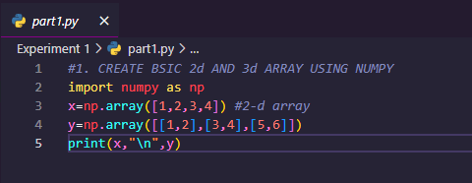 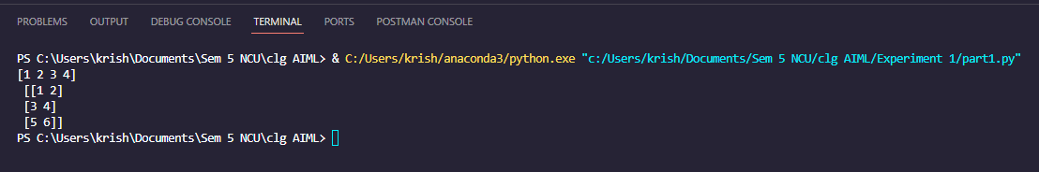

1. Use Pandas to create dictionary in python.

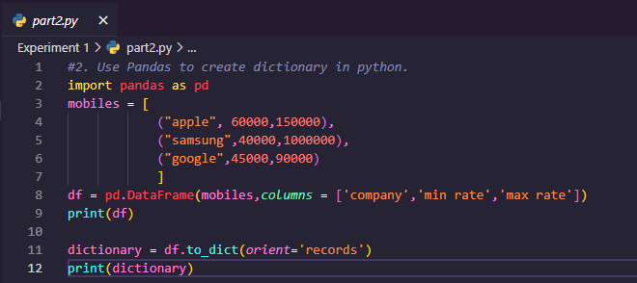 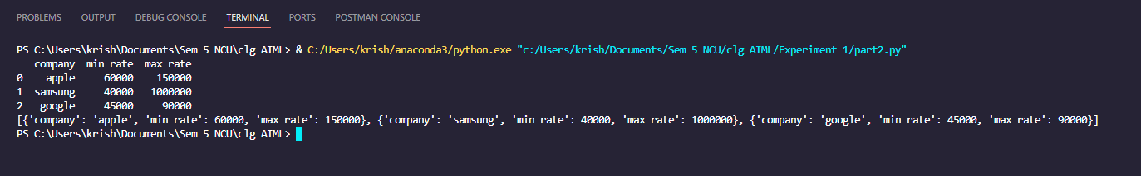

1. Use MatplotLib to plot one graph in python.

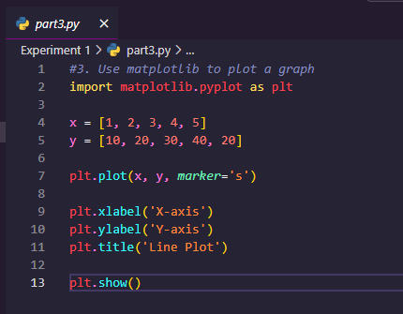

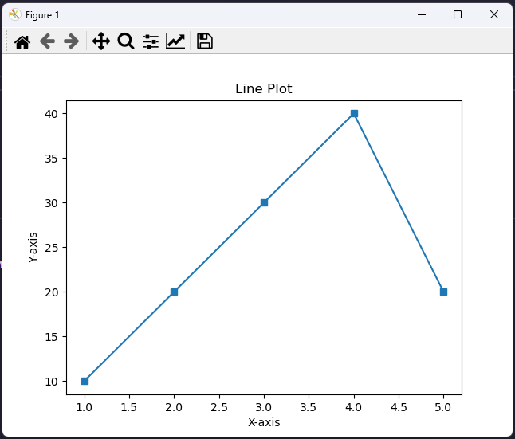

1. **Load an image and read it using scipy**

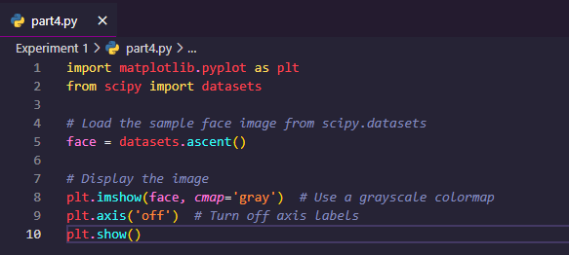





**EXPERIMENT NO. 2**

|  |
| --- |
| **Student Name and Roll Number:** Arjun Bhardwaj 21csu211 |
| **Semester /Section: FS-V-A** |
| **Link to Code:** |
| **Date: August 7th 2023** |
| **Faculty Signature:** |
| **Grade:** |

|  |
| --- |
| **Objective(s):**   * To understand the importance of data pre-processing techniques. * To handle missing values, duplicate values, feature scaling etc. |
| **Outcome:**  Students will be familiarized with the understanding and importance of applying various data pre-processing techniques. |
| **Problem Statement:**  Write a program to perform data pre-processing techniques for effective machine learning. |
| **Background Study:** Data preprocessing in Machine Learning is a crucial step thathelps enhance the quality of data to promote the extraction of meaningful insights from the data. Data preprocessing in Machine Learning refers to the technique of preparing (cleaning and organizing) the raw data to make it suitable for a building and training Machine Learning models.  1.data_set= pd.read_csv('Dataset.csv')  **data_set** is a name of the variable to store our dataset, and inside the function, we have passed the name of our dataset. Once we execute the above line of code, it will successfully import the dataset in our code.  **Scikit-learn** library in our code, which contains various libraries for building machine learning models |
| **Question Bank:**  1. What are different ways to handle missing values both for numerical as well as categorical data?   * **Handling Missing Numerical Data:**   + 1. **Deletion**   **Listwise Deletion**  **Pairwise Deletion**   * + 1. **Imputation**   **Mean/Median Imputation**  **Regression Imputation**  **K-Nearest Neighbors (KNN) Imputation**  **Interpolation**  **Random Sample Imputation**  **Predictive Modeling**   * + 1. **Missing Value Indicators**     2. **Random Sample Imputation**     3. **Predictive Modeling** * **Handling Missing Categorical Data:**   + 1. **Deletion**   **Listwise Deletion**  **Pairwise Deletion**   * + 1. **Imputation**   **Mode Imputation**  **Assign a New Category**  **Impute based on Conditional Probabilities**   * + 1. **Use the Missing Value Indicator**     2. **Random Sample Imputation**     3. **Predictive Modeling**     4. **Text Analysis**   2. What is the function in python used for finding duplicate rows in data?  **duplicated()**  3. Differentiate between two scaling methods used for feature scaling?  **Min-Max Scaling**  **Standardization (Z-score Scaling)** |

**Student Work Area**

**Algorithm/Flowchart/Code/Sample Outputs**

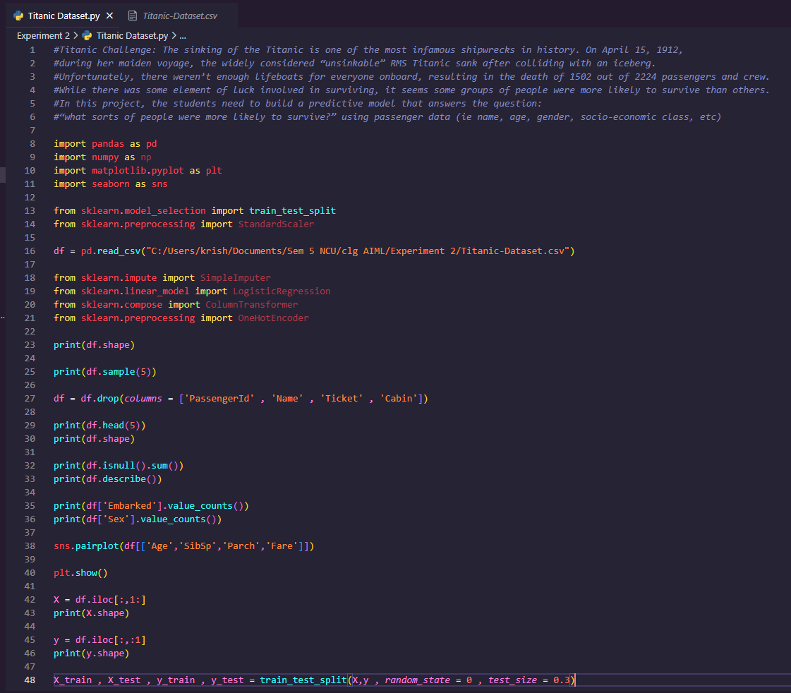

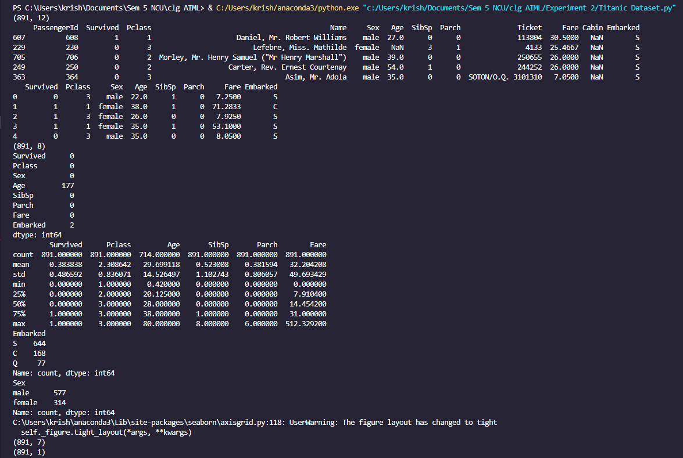

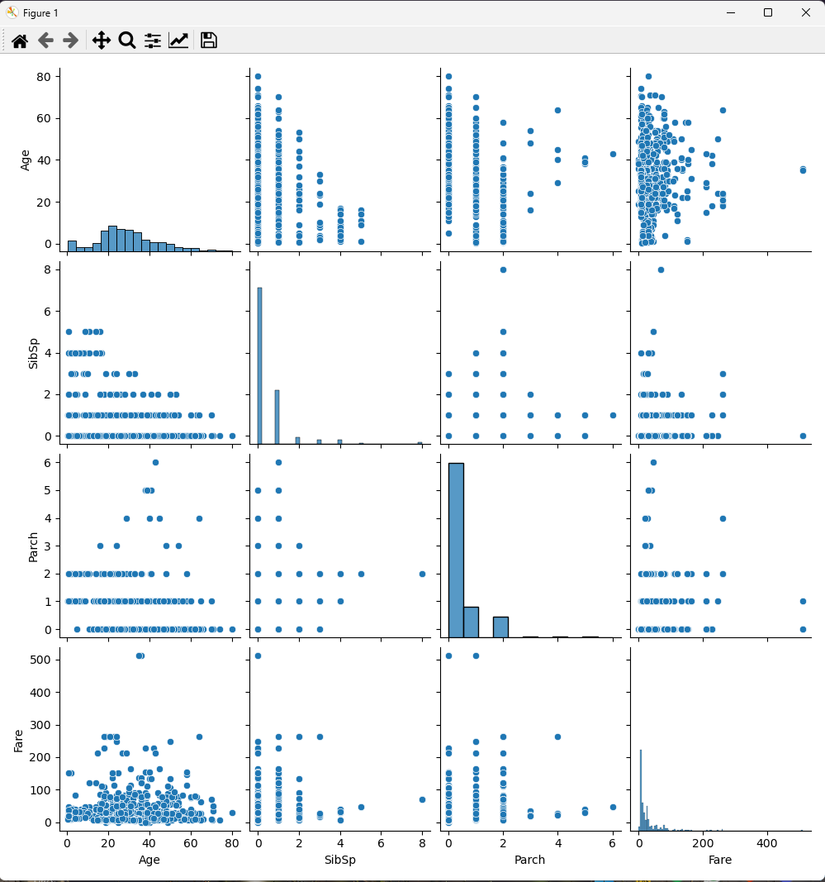

**EXPERIMENT NO. 3**

|  |
| --- |
| **Student Name and Roll Number:** Arjun Bhardwaj, 21csu211 |
| **Semester /Section: FS-V-A** |
| **Link to Code:** |
| **Date: August 17th 2023** |
| **Faculty Signature:** |
| **Grade:** |

|  |
| --- |
| **Objective(s):**   * To perform different encoding schemes. * To prepare dataset by converting categorical data to numeric form for machine learning. * To understand and implement label encoding and one hot encoding. |
| **Outcome:**  Students will be able to understand different encoding schemes to prepare data for machine learning. |
| **Problem Statement:**  To apply different feature encoding schemes on the given dataset. |
| **Background Study:** Machine learning models require all input and output variables to be numeric. This means that if your data contains categorical data, you must encode it to numbers **before you can fit and evaluate a model**. The two most popular techniques are Label Encoding and One-Hot Encoding.  **LabelEncoder()** class from **preprocessing** library. This class has successfully encoded the variables into digits.  **OneHotEncoder** class of **preprocessing** library: This class encodes all the variables into numbers 0 and 1 and divided into three columns. |
| **Question Bank:**  1. Can ML algorithms handle categorical data directly?  No, many ML algorithms cannot handle categorical data directly and require conversion to numerical form.  2. What are the different schemes for encoding categorical data?  Label Encoding  One Hot Encoding  Binary Encoding  Ordinal Encoding  Count Encoding  Target Encoding  3. Differentiate between Label Encoding and One Hot Encoding?  Label Encoding: Assigns a unique integer to each category. It's suitable for ordinal data but can introduce unintended ordinal relationships.  One Hot Encoding: Creates binary columns for each category, representing presence or absence. It's suitable for nominal data and avoids the ordinal relationship issue but can lead to a high dimensionality problem. |

**Student Work Area**

**Algorithm/Flowchart/Code/Sample Outputs**

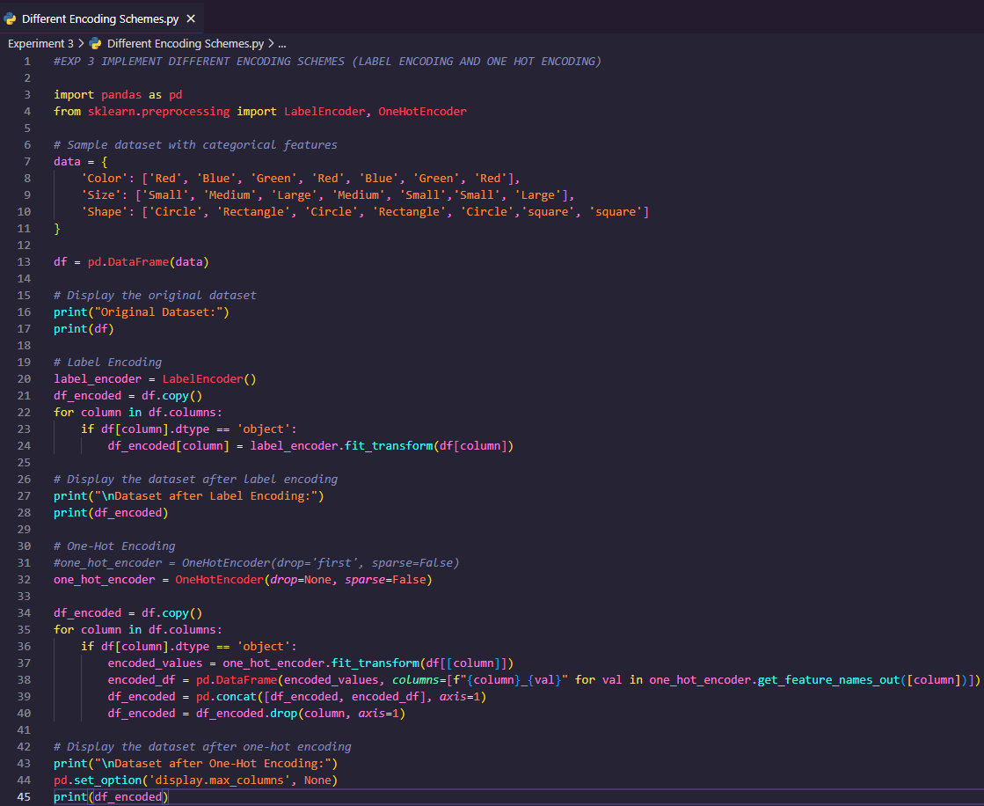

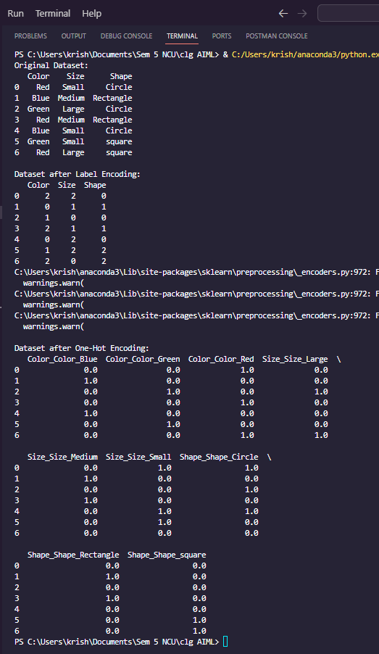

**EXPERIMENT NO. 4**

|  |
| --- |
| **Student Name and Roll Number: Arjun Bhardwaj 21csu211** |
| **Semester /Section: FS-V-A** |
| **Link to Code:** |
| **Date: August 24th, 2023** |
| **Faculty Signature:** |
| **Grade:** |

|  |  |  |  |  |  |
| --- | --- | --- | --- | --- | --- |
| |  | | --- | | **Objective(s):**   * To understand the importance of feature selection * To differentiate between different types of feature selection. * Build a model using feature selection techniques. | | **Outcome:**  Students will be familiarized with model building using feature selection techniques and  optimization. | | **Problem Statement:**  Write a program to apply filter feature selection techniques. | | **Background Study:** Feature selection is the process of reducing the number of input variables when developing a predictive model. It is desirable to reduce the number of input variables to both reduce the computational cost of modeling and, in some cases, to improve the performance of the model. | | **Question Bank:**  1. What are different filter feature selection techniques?  Filter feature selection techniques evaluate each feature independently and assign scores based on their statistical properties or relationships with the target variable. Common methods include correlation-based selection, mutual information, chi-squared tests, ANOVA, information gain, and variance thresholding. These techniques are efficient for initial feature reduction but may not capture feature interactions.  2. How feature selection techniques depend on the data type of input features and output variable?  Feature selection techniques depend on the data types of input features and the type of modeling task. For numerical features, methods like correlation, mutual information, and ANOVA are common. Categorical features often use chi-squared tests and information gain. For mixed data types, a combination of techniques may be needed. Time series, text, image, and sensor data may require domain-specific methods. The choice depends on the specific data characteristics and modeling objectives.  3. What is the mathematics behind Pearson’s Correlation to rank features?  To rank features using Pearson's correlation coefficient (r):  1)Calculate r for each feature and the target variable.  2)Higher absolute values of r indicate stronger linear relationships.  3)Rank features based on the absolute values of their correlation coefficients, with higher values considered more relevant to the target. | |
|  |
|  |

**Student Work Area**

**Algorithm/Flowchart/Code/Sample Outputs**

**# Pearson’s Correlation with f_regression function**

**# Creating regression dataset with make_regression function**

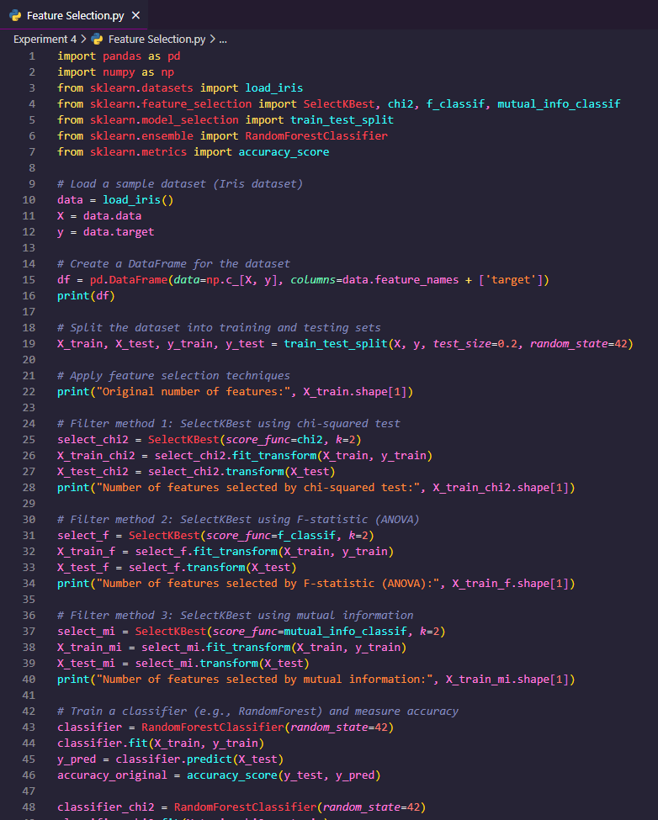 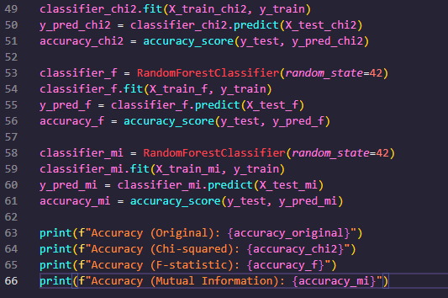 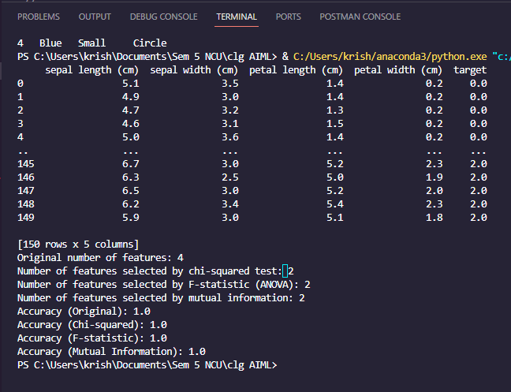

**EXPERIMENT NO. 5**

|  |
| --- |
| **Student Name and Roll Number:** Arjun Bhardwaj |
| **Semester /Section: FS-V-A** |
| **Link to Code:** |
| **Date: August 28th, 2023** |
| **Faculty Signature:** |
| **Grade:** |

|  |
| --- |
| **Objective(s):**   * Study Dimensionality Reduction. * Understand the basic principle behind Principal Component Analysis. |
| **Outcome:**  Students will be familiarized with Dimensionality Reduction especially Principal Component  Analysis (PCA). |
| **Problem Statement:**  Reduce dimensionality of Iris dataset using Principal Component Analysis. |
| **Background Study:** Principal component analysis is a statistical technique that is used to analyze the interrelationships among a large number of variables and to explain these variables in terms of a smaller number of variables, called principal components, with a minimum loss of information.  PCA is affected by scale so you need to scale the features in your data before applying PCA. Use StandardScaler to help you standardize the dataset’s features onto unit scale (mean = 0 and variance = 1) which is a requirement for the optimal performance of many machine learning algorithms.  **StandardScaler**to help you standardize the dataset’s features onto unit scale (mean = 0 and variance = 1) which is a requirement for the optimal performance of many machine learning algorithms.  **explained_variance_ratio_**: helps to visualize the first principal component contains of the variance and the second principal component contains of the variance. Together, the two components of the information. |
| **Question Bank:**  1. What is dimensionality reduction?  Dimensionality reduction refers to the process of reducing the number of features (attributes or variables) in a dataset while retaining the most important information. It is often used to address the "curse of dimensionality," improve computational efficiency, reduce noise, and enhance the interpretability of data. Principal Component Analysis (PCA) is a common technique for dimensionality reduction.  2. Differentiate between Feature Selection, Feature Engineering and Dimensionality Reduction.  Feature Selection: Feature selection is the process of choosing a subset of the most relevant and informative features from the original set of features. It aims to eliminate irrelevant, redundant, or less important features to improve model performance and reduce overfitting.  Feature Engineering: Feature engineering involves creating new features or transforming existing ones to improve the performance of machine learning models. This can include creating interaction terms, scaling, encoding categorical variables, and generating domain-specific features.  Dimensionality Reduction: Dimensionality reduction is a specific form of feature engineering, which focuses on reducing the number of features by creating a new set of variables (principal components) that capture most of the variance in the data. It is particularly useful when dealing with high-dimensional data.  3. What are principal components?  Principal components are the linear combinations of the original features in a dataset that capture the maximum variance in the data. Principal Component Analysis (PCA) is a dimensionality reduction technique that generates these components. The first principal component accounts for the most variance, the second for the second most, and so on. Principal components are orthogonal to each other, which means they are uncorrelated. They are used to reduce the dimensionality of data while retaining as much information as possible. |

**Student Work Area**

**Algorithm/Flowchart/Code/Sample Outputs**

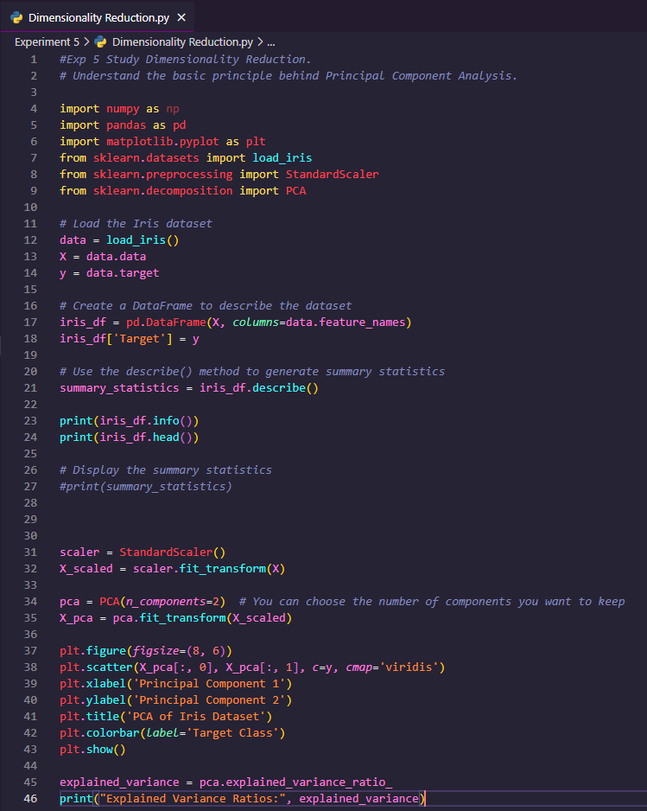 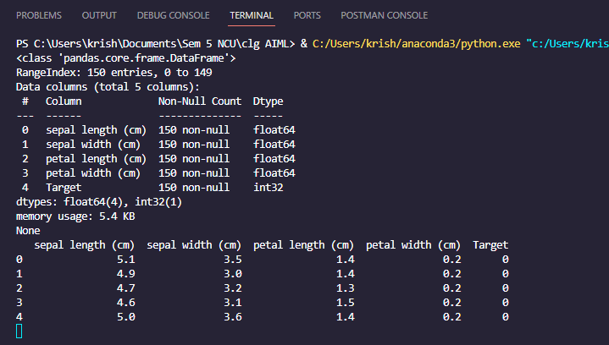

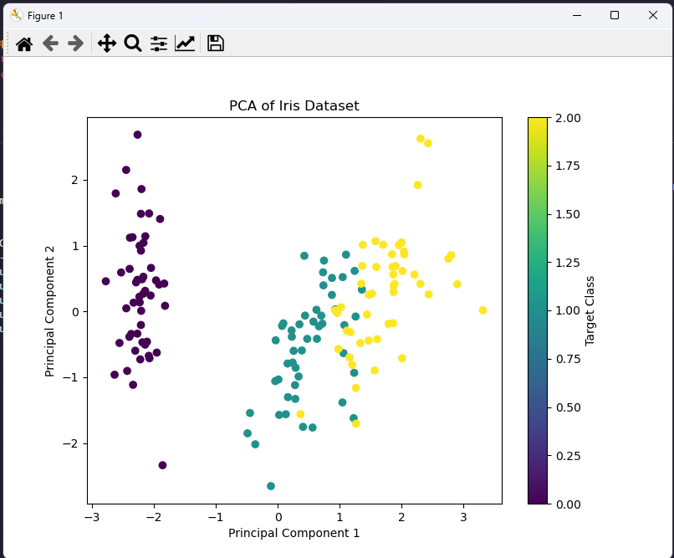

**EXPERIMENT NO. 6**

|  |
| --- |
| **Student Name and Roll Number:** Arjun Bhardwaj |
| **Semester /Section: FS-V-A** |
| **Link to Code:** |
| **Date: September 11th, 2023** |
| **Faculty Signature:** |
| **Grade:** |

|  |
| --- |
| **Objective(s):**   * Understand Simple Linear Regression (SLR). * Study about the different performance metrics of SLR. |
| **Outcome:**  Student will be familiarized with regression problems and SLR as a solution to single feature problem. |
| **Problem Statement:**  To apply Simple Linear Regression on the given dataset. |
| **Background Study:**  Simple linear regression isan approach for predicting a response using a single feature. It is assumed that the two variables are linearly related. Hence, we try to find a linear function that predicts the response value(y) as accurately as possible as a function of the feature or independent variable(x).  [statsmodels](https://www.statsmodels.org/stable/index.html) — a module that provides classes and functions for the estimation of many different statistical models, as well as for conducting statistical tests, and statistical data exploration.  [scikit-learn](http://scikit-learn.org/stable/) — a module that provides simple and efficient tools for data mining and data analysis.  Calling model.params will show us the model’s parameters. |
| **Question Bank:**  1. What is a regression problem?  A regression problem involves predicting a continuous output variable based on input features.  2. How Simple Linear Regression (SLR) helps in solving regression problems containing an input feature and an output variable?  Simple Linear Regression (SLR) models the relationship between one input feature and an output variable using a linear equation.  3. What are the different performance metrics that can be used for evaluating SLR?  Performance metrics for evaluating SLR include Mean Absolute Error (MAE), Mean Squared Error (MSE), Root Mean Squared Error (RMSE), R-squared (R²), and Adjusted R-squared, which assess model accuracy and goodness of fit. |

**Student Work Area**

**Algorithm/Flowchart/Code/Sample Outputs**

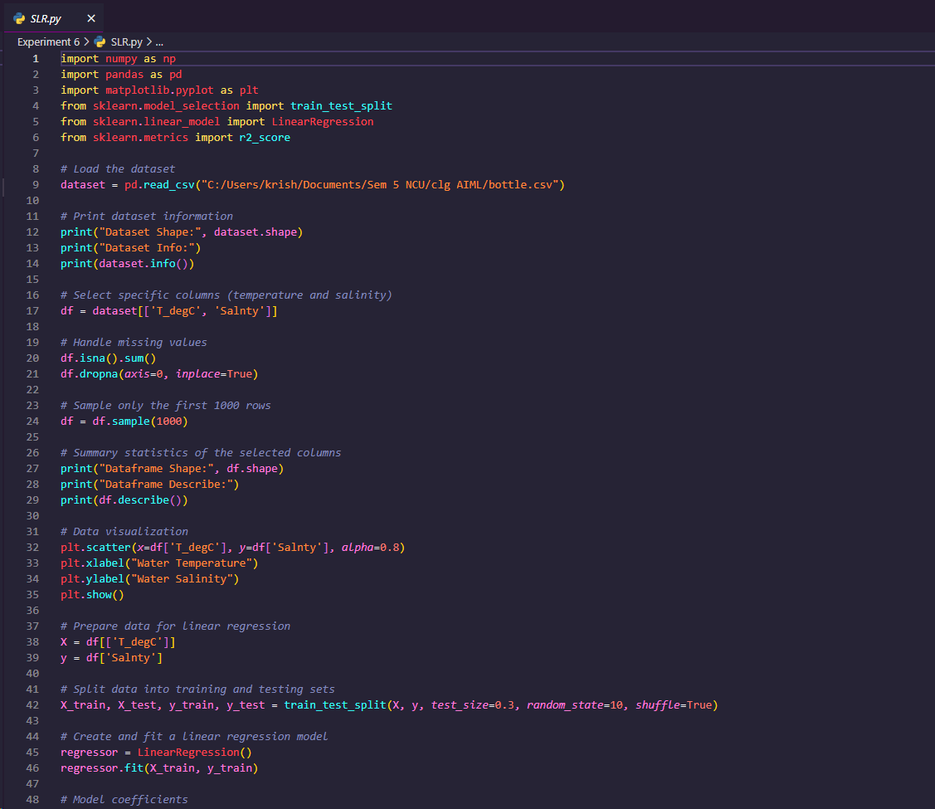

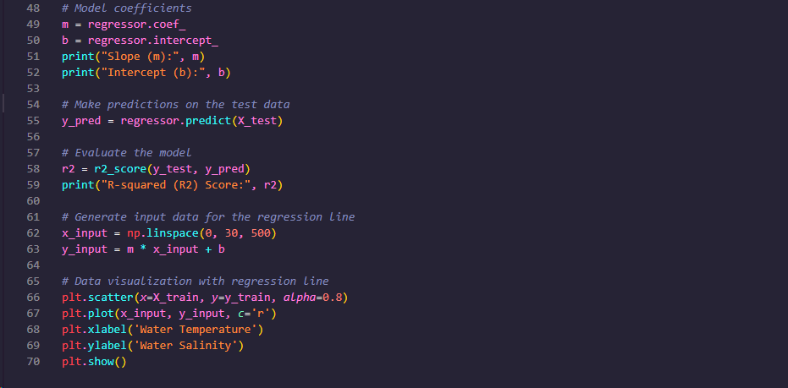

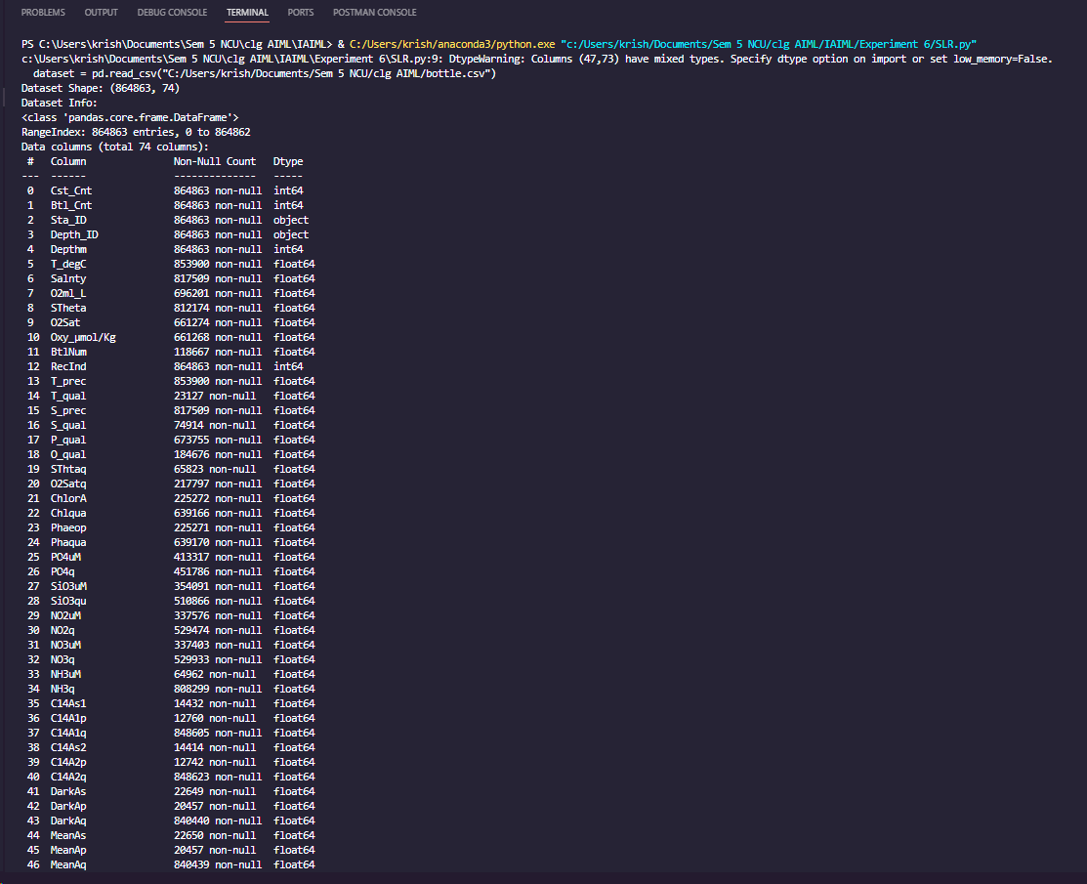

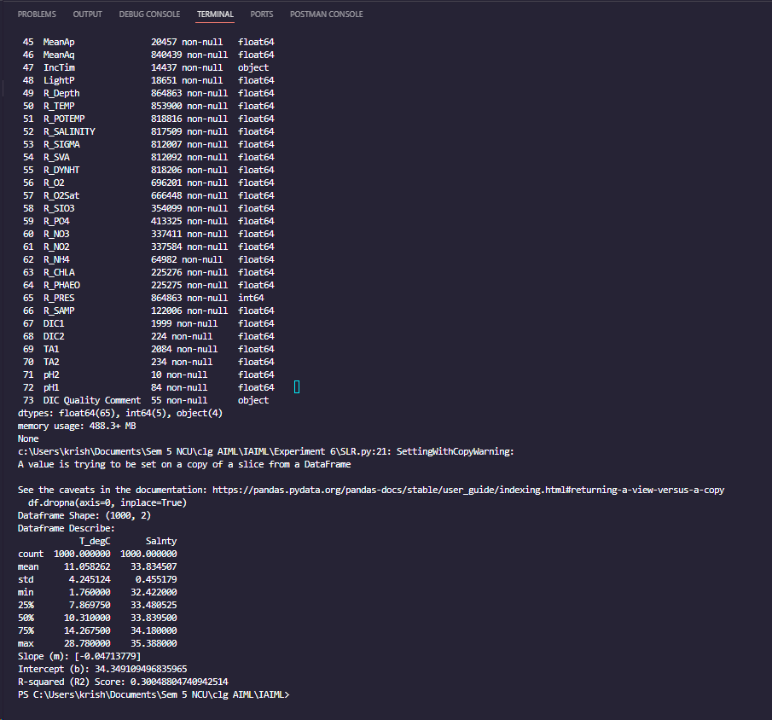

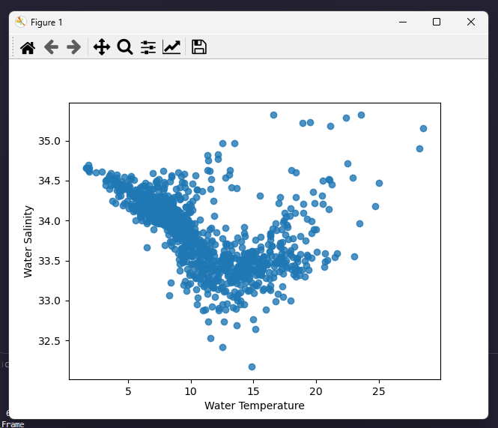

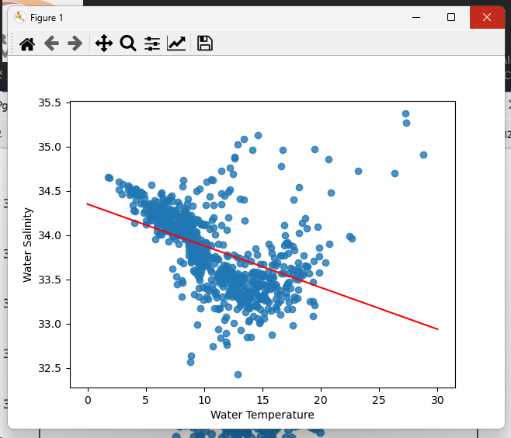

**EXPERIMENT NO. 7**

|  |
| --- |
| **Student Name and Roll Number:** Arjun Bhardwaj |
| **Semester /Section:FS-V-A** |
| **Link to Code:** |
| **Date: September 18th 2023** |
| **Faculty Signature:** |
| **Grade:** |

|  |
| --- |
| **Objective(s):**   * Understand mathematics behind Multiple Linear Regression (MLR). * Solving linear regression problems containing more than one independent feature using MLR. |
| **Outcome:**  Students will be familiarized with Multiple Linear Regression for solving linear regression problems. |
| **Problem Statement:**  To apply multiple linear regression on any regression dataset. |
| **Background Study:**  Multiple Linear Regressionattempts to model the relationship between two or more features and a response by fitting a linear equation to observed data. Statsmodels is a Python module that provides classes and functions for the estimation of different statistical models, as well as different statistical tests. [statsmodels](https://www.statsmodels.org/stable/index.html) — a module that provides classes and functions for the estimation of many different statistical models, as well as for conducting statistical tests, and statistical data exploration. |
| **Question Bank:**  1. What is MLR?  Multiple Linear Regression (MLR) is a statistical and machine learning technique used to model the relationship between a dependent variable and multiple independent variables. It extends Simple Linear Regression (SLR) to accommodate more than one predictor, allowing for a more complex modeling of relationships between variables.  2. Differentiate between SLR and MLR?  Simple Linear Regression (SLR):  SLR models the relationship between a single independent variable (predictor) and a dependent variable.  SLR is suitable when you want to understand the linear relationship between two variables.  Multiple Linear Regression (MLR):  MLR models the relationship between a dependent variable and multiple independent variables.  MLR allows you to account for the influence of multiple predictors on the dependent variable simultaneously, making it suitable for more complex modeling.  In summary, SLR focuses on a single predictor, while MLR can handle multiple predictors, providing a more comprehensive analysis of relationships between variables in a multivariate context. |

**Student Work Area**

**Algorithm/Flowchart/Code/Sample Outputs**

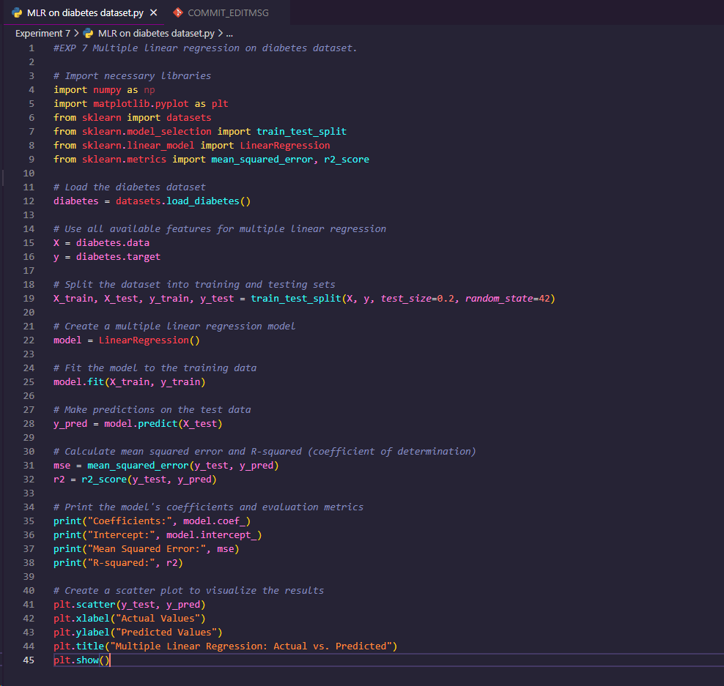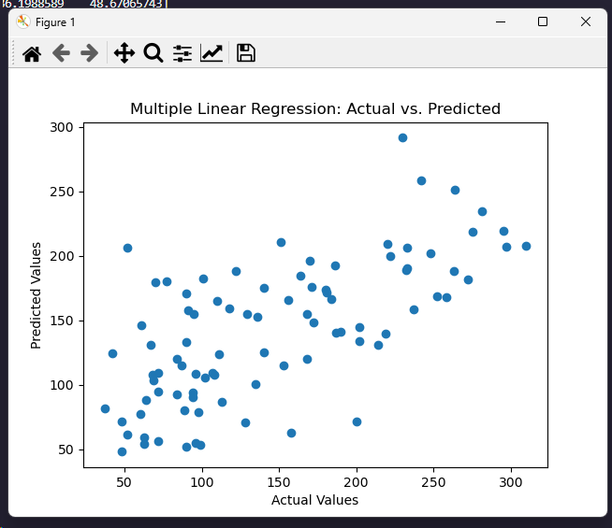

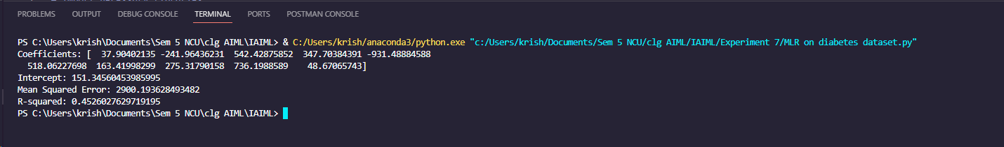

**EXPERIMENT NO. 8**

|  |
| --- |
| **Student Name and Roll Number: Arjun Bhardwaj 21csu211** |
| **Semester /Section: FS-V-A** |
| **Link to Code:** |
| **Date: September 25th,** |
| **Faculty Signature:** |
| **Grade:** |

|  |
| --- |
| **Objective(s):**   * Study and understand about Polynomial Regression on non-linear regression data. * Study the mathematics behind Polynomial Regression. |
| **Outcome:**  Students will be familiarized with handling of regression data having non-linear relationship between input and output. |
| **Problem Statement:**  To apply Polynomial Linear Regression on the given dataset. |
| **Background Study:**  **Polynomial Regression**is a form of linear regression in which the relationship between the independent variable x and dependent variable y is modeled as an nth degree polynomial. Polynomial regression fits a nonlinear relationship between the value of x and the corresponding conditional mean of y, denoted E(y |x). [statsmodels](https://www.statsmodels.org/stable/index.html) — a module that provides classes and functions for the estimation of many different statistical models, as well as for conducting statistical tests, and statistical data exploration. |
| **Question Bank:**  What is non-linear relationship between input and output?  A non-linear relationship between input and output refers to a situation where the change in the output variable is not proportional to the change in the input variable(s). In other words, the relationship between the input and output cannot be accurately represented by a straight line.  Contrastingly, a linear relationship implies that a change in the input results in a constant or proportional change in the output, and this relationship can be effectively captured by a straight line in a two-dimensional space or a hyperplane in a higher-dimensional space.  How Polynomial Regression is used to handle non-linear relationship?  Polynomial Regression is a technique used to model the relationship between independent variables (inputs) and the dependent variable (output) when the relationship is non-linear. It extends the idea of linear regression by introducing polynomial terms, allowing the model to capture more complex patterns in the data. Instead of fitting a straight line, Polynomial Regression fits a polynomial function to the data. |

**Student Work Area**

**Algorithm/Flowchart/Code/Sample Outputs**

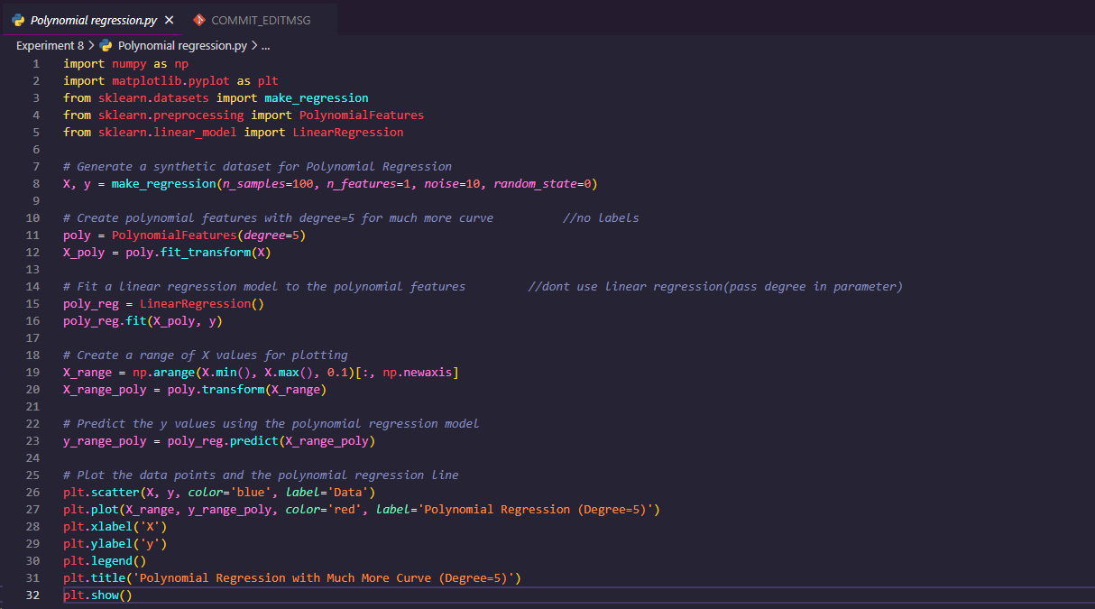

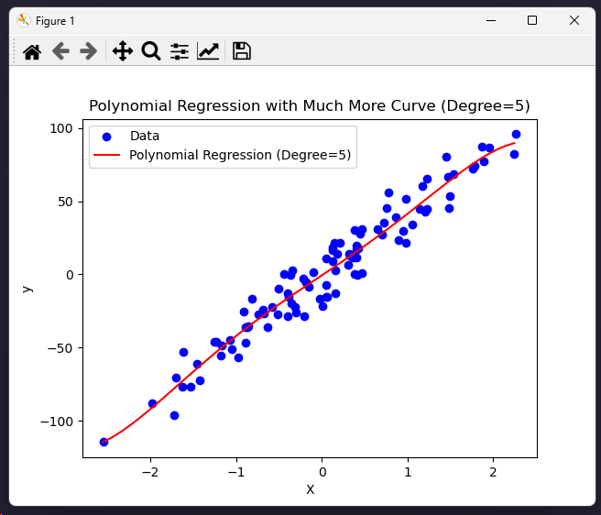

**EXPERIMENT NO. 9**

|  |
| --- |
| **Student Name and Roll Number: Arjun Bhardwaj 21csu211** |
| **Semester /Section: FS-V-A** |
| **Link to Code:** |
| **Date: October 23th, 2023** |
| **Faculty Signature:** |
| **Grade:** |

|  |
| --- |
| **Objective(s):**   * Study Logistic Regression. * How Logistic Regression is used to solve classification problems. |
| **Outcome:**  Students will be familiarized with Logistic Regression and performance metrics to calculate its performance on the given dataset. |
| **Problem Statement:**  To solve classification problems using Logistic Regression. |
| **Background Study:**  Logistic regression is a classification technique which helps to predict the probability of an outcome that can only have two values. Logistic Regression is used when the dependent variable (target) is categorical. A logistic regression produces a logistic curve, which is limited to values between 0 and 1.  confusion_matrix and accuracy_score functions are used to evaluate the model. A confusion matrix is visualized using a heatmap from the seaborn package, and Boxplot from seaborn is used to check for the outliers in the dataset. The confusion matrix consists of the matrix elements with True Positive, True Negative, False Positive, and False Negative values. |
| **Question Bank:**  Q1) What is Logistic Regression?  Logistic Regression is a statistical method used for binary classification problems, where the output variable takes on two possible outcomes, often coded as 0 and 1. Despite its name, logistic regression is used for classification, not regression.  Q2) How Logistic Regression is used for solving classification problems?  Logistic Regression is a powerful and widely used method for solving binary and multiclass classification problems. Here's how Logistic Regression is applied to solve classification problems:  1. Formulation of the Logistic Regression Model:  The logistic regression model is based on the logistic function (sigmoid function), which transforms a linear combination of input features into a probability score between 0 and 1.  2. Training the Logistic Regression Model:  The model is trained using a dataset with labeled examples (inputs and corresponding class labels). The process involves finding the optimal values for the coefficients that maximize the likelihood of the observed data. This is typically done by minimizing the cross-entropy loss function, also known as log loss.  3. Prediction:  Once the model is trained, it can be used to make predictions on new, unseen data. The output of the logistic regression model is a probability score (  P(Y=1)) for each input. A common threshold is 0.5; if the predicted probability is greater than 0.5, the input is classified as belonging to class 1; otherwise, it is classified as belonging to class 0.  4. Evaluation:  The performance of the Logistic Regression model is assessed using various evaluation metrics, such as accuracy, precision, recall, F1 score, and area under the Receiver Operating Characteristic (ROC) curve.  5. Regularization:  To prevent overfitting, regularization techniques like L1 or L2 regularization can be applied. Regularization adds a penalty term to the loss function, discouraging overly complex models.  6. Multiclass Classification:  Logistic Regression can be extended to handle multiclass classification problems using techniques like one-vs-all (OvA) or one-vs-one (OvO). In OvA, multiple binary classifiers are trained, each distinguishing one class from the rest. In OvO, a binary classifier is trained for each pair of classes.  7. Interpretability:  One of the advantages of Logistic Regression is its interpretability. The coefficients provide insights into the impact of each feature on the log-odds of the outcome.  Q3. Why sigmoid function is used in it?  The sigmoid function, also known as the logistic function, is used in Logistic Regression because it transforms a linear combination of input features into a range between 0 and 1. This property is essential for modeling probabilities in a classification setting, where the goal is to predict the probability of an instance belonging to a particular class. |

**Student Work Area**

**Algorithm/Flowchart/Code/Sample Outputs**

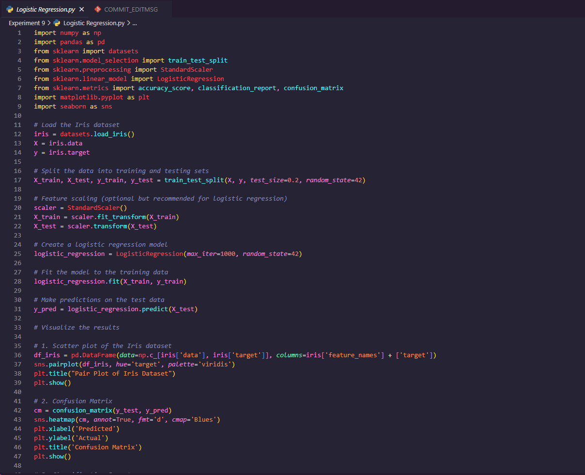



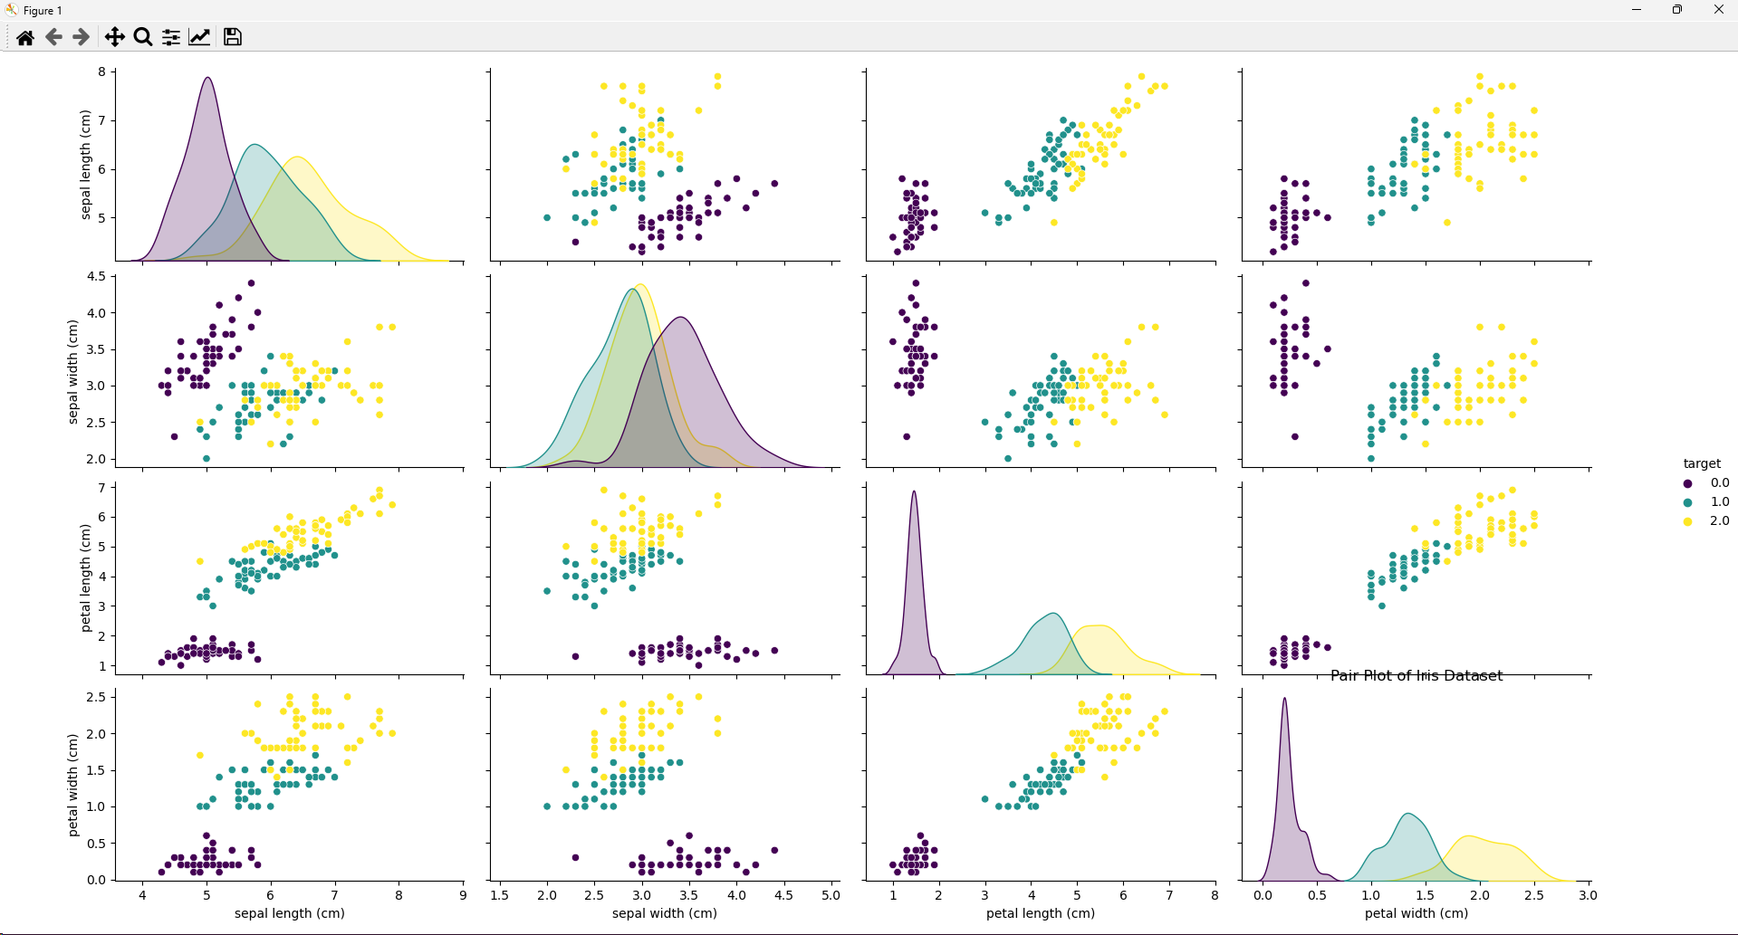

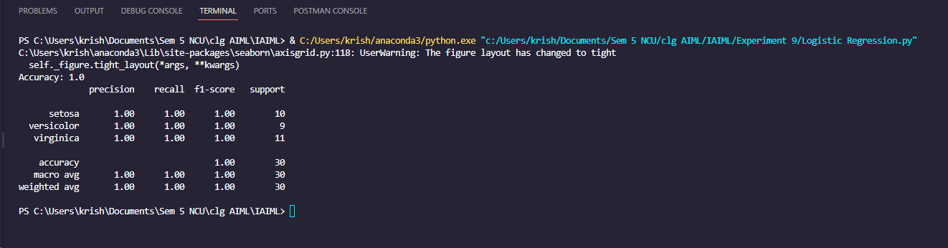

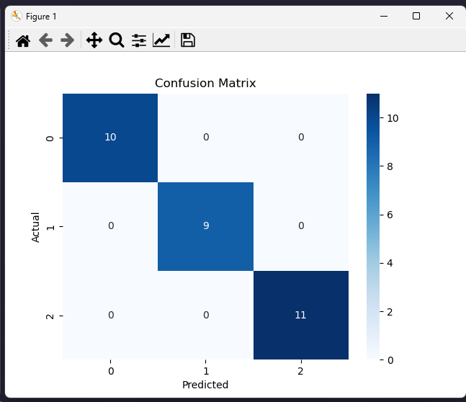

**EXPERIMENT NO. 10**

|  |
| --- |
| **Student Name and Roll Number: Arjun Bhardwaj 21csu211** |
| **Semester /Section: FS-V-A** |
| **Link to Code:** |
| **Date: October 30th, 2023** |
| **Faculty Signature:** |
| **Grade:** |

|  |
| --- |
| **Objective(s):**   * Study K-Nearest Neighbor algorithm (KNN). * Understand the working principle behind KNN. |
| **Outcome:**  Students will be familiarized with classification technique using KNN. |
| **Problem Statement:**  To solve classification problems using KNN classification. |
| Background Study:  K-nearest neighbors (KNN) algorithm is a type of supervised ML algorithm which can be used for both classification as well as regression predictive problems. However, it is mainly used for classification predictive problems in industry. The following two properties would define KNN well −   * Lazy learning algorithm − KNN is a lazy learning algorithm because it does not have a specialized training phase and uses all the data for training while classification. * Non-parametric learning algorithm − KNN is also a non-parametric learning algorithm because it doesn’t assume anything about the underlying data.   K-nearest neighbors (KNN) algorithm uses ‘feature similarity’ to predict the values of new datapoints which further means that the new data point will be assigned a value based on how closely it matches the points in the training set. The most common parameter used to perform matching is Euclidean distance between the points.  The sklearn library has provided a layer of abstraction on top of Python. Therefore, in order to make use of the KNN algorithm, it’s sufficient to create an instance of KNeighborsClassifier. By default, the KNeighborsClassifier looks for the **5** nearest neighbors. We must explicitly tell the classifier to use Euclidean distance for determining the proximity between neighboring points. |
| **Question Bank:**  Q1) What is KNN classifier?  The k-Nearest Neighbors (KNN) classifier is a type of instance-based or lazy learning algorithm used for classification and regression tasks. In the context of classification, KNN is particularly popular. The basic idea behind KNN is to classify a new data point based on the majority class of its k nearest neighbors in the feature space.  Q2) How KNN makes use of Euclidean distance to calculate nearest neighbor?  K-Nearest Neighbors (KNN) uses the Euclidean distance to measure the similarity or dissimilarity between data points in order to find the k-nearest neighbors. Euclidean distance is a commonly used metric in KNN, especially when dealing with continuous features.    Q3) What are the other distances that can be used for nearest neighbor? In addition to Euclidean distance, there are several other distance metrics that can be used for nearest neighbor algorithms, including K-Nearest Neighbors (KNN). The choice of distance metric depends on the nature of the data and the characteristics of the problem at hand. Here are some common distance metrics used in nearest neighbor algorithms:  1. Manhattan Distance (L1 Norm):  Also known as city block distance or taxicab distance.  Defined as the sum of the absolute differences between corresponding coordinates.  2. Minkowski Distance:  A generalization of both Euclidean and Manhattan distances.  3. Chebyshev Distance (L∞ Norm):  The maximum absolute difference between corresponding coordinates.  4. Hamming Distance (for categorical data):  Measures the number of positions at which corresponding bits are different.  And many more  Q4) What are the various performance metrics used for classification problems?  Several performance metrics are commonly used to evaluate the performance of classification models. The choice of metric depends on the specific characteristics of the problem and the goals of the analysis. Here are some key performance metrics for classification problems: |

**Student Work Area**

**Algorithm/Flowchart/Code/Sample Outputs**

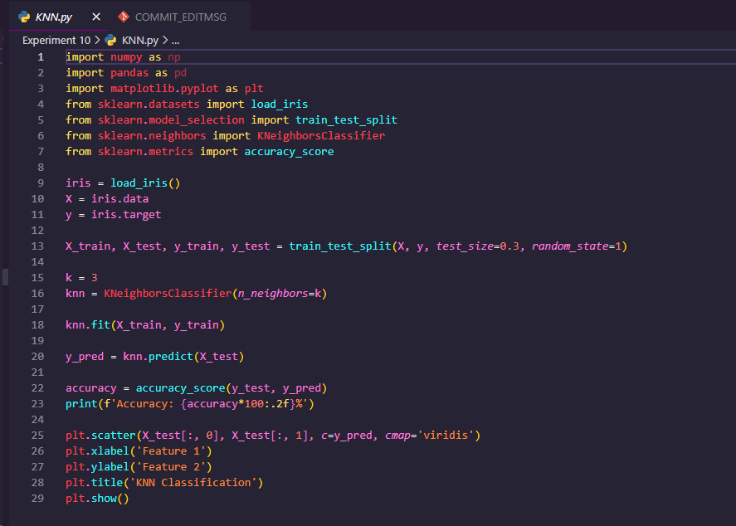

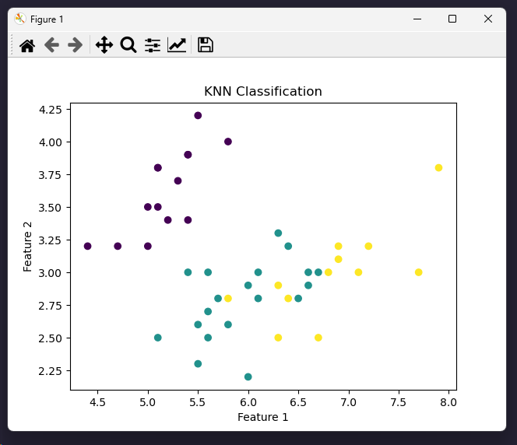



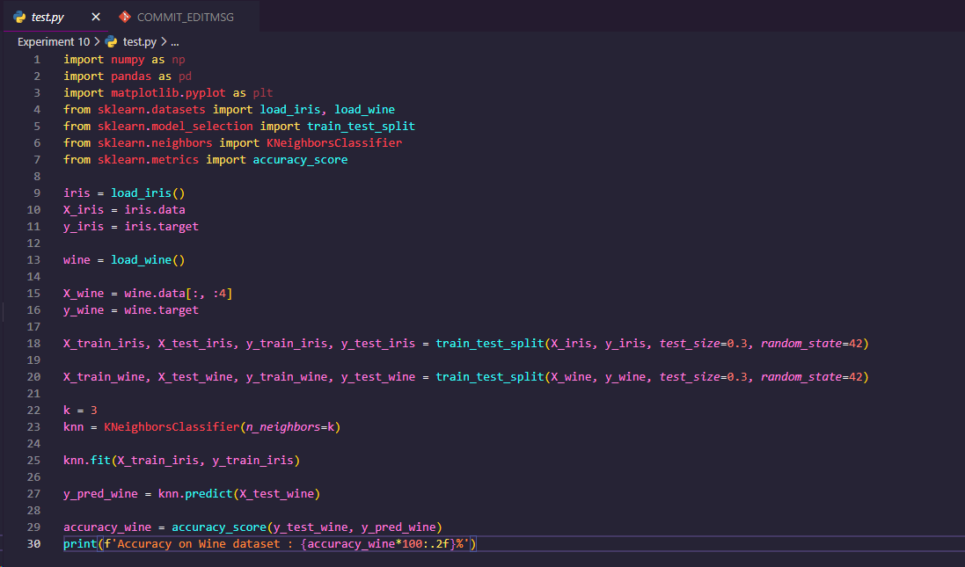

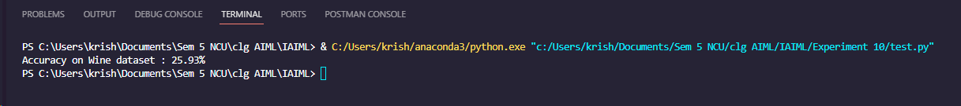

**EXPERIMENT NO. 11**

|  |
| --- |
| **Student Name and Roll Number: Arjun Bhardwaj 21csu211** |
| **Semester /Section: FS-V-A** |
| **Link to Code:** |
| **Date: November 6th, 2023** |
| **Faculty Signature:** |
| **Grade:** |

|  |
| --- |
| **Objective(s):**   * Understand and study Naïve Bayes (NB) Classifier. * Understand Naïve Bayes theorem behind it. |
| **Outcome:**  Students will be familiarized with NB classification technique. |
| **Problem Statement:**  To solve classification problems using Naïve Bayes. |
| **Background Study:**  Naïve Bayes Classifier is a probabilistic classifier and is based on Bayes Theorem.  In Machine learning, a classification problem represents the selection of the Best Hypothesis given the data.  Given a new data point, we try to classify which class label this new data instance belongs to. The prior knowledge about the past data helps us in classifying the new data point. The Naïve Bayes theorem:    gives us the probability of Event A to happen given that event B has occurred.  The receiver operating characteristic curve also known as roc_curve is a plot that tells about the interpretation potential of a binary classifier system. It is plotted between the true positive rate and the false positive rate at different thresholds. |
| **Question Bank:**  Q1) What is Bayes theorem?  Bayes' Theorem is a fundamental principle in probability theory that describes the relationship between the conditional and marginal probabilities of random events. Named after the Reverend Thomas Bayes, the theorem provides a way to update probabilities based on new evidence.    Q2) How Naïve Bayes classifier helps for solving classification problems?  The Naive Bayes classifier is a probabilistic machine learning algorithm that is particularly well-suited for classification problems. It is based on Bayes' Theorem and makes an assumption of independence among the features, leading to its "naive" designation. Despite this simplifying assumption, Naive Bayes often performs well and is computationally efficient. Here's how the Naive Bayes classifier helps in solving classification problems:  1. Bayesian Framework:  Naive Bayes is grounded in Bayes' Theorem, which provides a probabilistic framework for making predictions based on prior knowledge and observed evidence. It allows for the incorporation of prior beliefs and the updating of probabilities as new data becomes available.  2. Independence Assumption:  The "naive" assumption in Naive Bayes is that the features used for classification are conditionally independent given the class label. While this assumption may not hold in reality, it simplifies the modeling process and often works well in practice. The independence assumption makes the algorithm computationally efficient, especially for high-dimensional datasets.  3. Text Classification and NLP:  Naive Bayes is commonly used for text classification tasks, such as spam filtering and sentiment analysis. It performs well with high-dimensional and sparse data, making it suitable for scenarios where the number of features (e.g., words in a document) is large.  4. Multinomial Naive Bayes:  In the case of text classification, the Multinomial Naive Bayes variant is often used. It assumes that features represent the frequency of words in a document and follows a multinomial distribution. This is well-suited for tasks involving discrete data, such as word counts.  5. Gaussian Naive Bayes:  Another variant is the Gaussian Naive Bayes, which assumes that continuous features follow a Gaussian (normal) distribution. This is applicable when dealing with continuous numerical data.  6. Handling Missing Data:  Naive Bayes is capable of handling missing data gracefully. The absence of a feature for a particular instance does not disrupt the probability calculations.  7. Efficiency and Speed:  Naive Bayes is computationally efficient and has a fast training and prediction time. This makes it suitable for large datasets and real-time applications.  8. Small Training Data:  Naive Bayes can perform well even with small amounts of training data. This is particularly advantageous in situations where acquiring labeled training data is challenging.  9. Interpretability:  The model is interpretable, and the probabilities assigned to different classes provide insights into the likelihood of each class given the observed features.  Q3) What is the condition on features that should be fulfilled for successful application of Naïve Bayes method?  The Naive Bayes algorithm makes the assumption that features are conditionally independent given the class label. This is known as the "naive" assumption, and it simplifies the modeling process. However, for the Naive Bayes method to perform well, certain conditions or characteristics of the data should be considered:  Independence Assumption:  The primary assumption of Naive Bayes is that features are independent given the class label. This means that the presence or absence of a particular feature does not influence the presence or absence of any other feature. While this assumption may not hold in reality, Naive Bayes can still perform well if the dependencies among features are not strong.  Sufficient Data:  Naive Bayes tends to perform well when there is sufficient training data available. The more data available for estimating probabilities, the better the model can capture the underlying patterns.  Feature Types:  Naive Bayes can handle both categorical and continuous features. However, it is essential to choose the appropriate variant based on the nature of the data:  Multinomial Naive Bayes: Suitable for discrete features, often used in text classification where features represent word frequencies.  Gaussian Naive Bayes: Appropriate for continuous numerical features, assuming a Gaussian distribution.  Handling of Missing Data:  Naive Bayes can handle missing data effectively. The absence of a particular feature for an instance does not disrupt the probability calculations.  Not Sensitive to Irrelevant Features:  Naive Bayes is generally not sensitive to irrelevant features because the independence assumption reduces the impact of irrelevant features on the classification.  Balanced Class Distribution:  Naive Bayes can be sensitive to imbalanced class distributions. If one class has significantly more instances than another, the model may be biased toward the majority class.  Appropriate Preprocessing:  Feature scaling is not typically required for Naive Bayes because the algorithm is not sensitive to the scale of features. However, appropriate preprocessing, such as handling outliers or encoding categorical variables, is still important.  Weak Feature Dependencies:  While Naive Bayes can handle some level of feature dependence, it performs better when dependencies are weak. Strong dependencies may lead to inaccuracies in probability estimates.  Text Classification and Natural Language Processing (NLP):  Naive Bayes is particularly well-suited for text classification tasks in NLP, where features represent word frequencies. The algorithm often performs well in such scenarios.  Small Training Data:  Naive Bayes can work well even with small amounts of training data, making it useful in situations where acquiring large labeled datasets is challenging. |

**Student Work Area**

**Algorithm/Flowchart/Code/Sample Outputs**

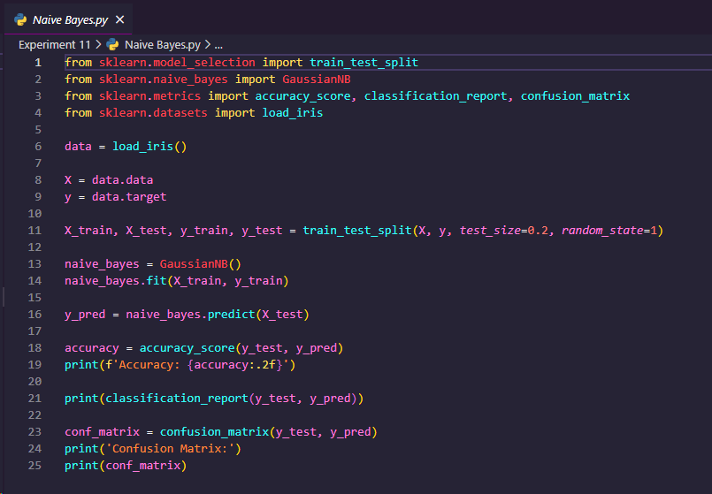

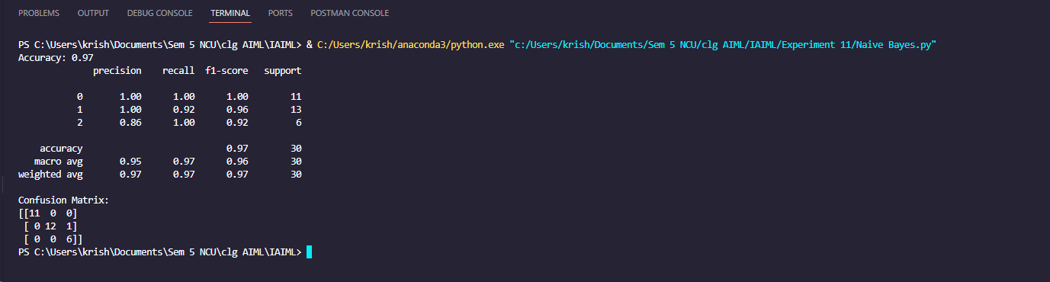

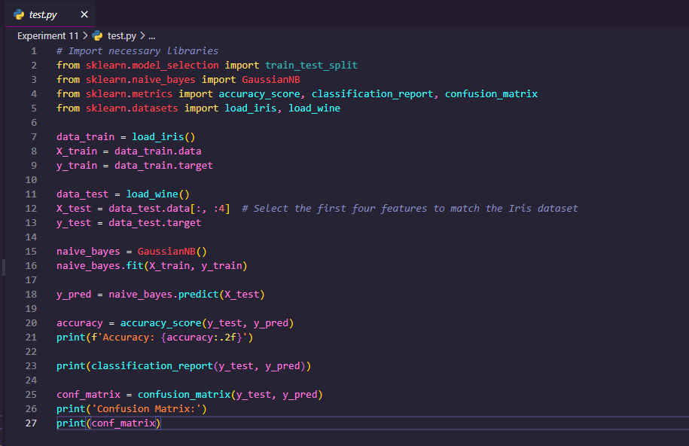

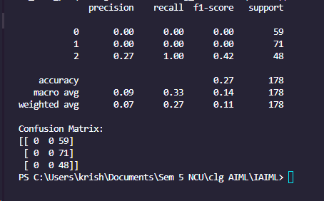

**EXPERIMENT NO. 12**

|  |
| --- |
| **Student Name and Roll Number:** |
| **Semester /Section:** |
| **Link to Code:** |
| **Date:** |
| **Faculty Signature:** |
| **Grade:** |

|  |
| --- |
| **Objective(s):**   * Understand and study Support Vector Machines (SVM). * To study how linear hyperplane is calculated to differentiate between two classes. * Basic understanding of the different variants of SVM. |
| **Outcome:**  Students will be familiarized with Support Vector Machines classifier. |
| **Problem Statement:**  To solve classification problems using SVM. |
| **Background Study:**  In machine learning, support-vector machines (SVMs, also support-vector networks) are supervised learning models with associated learning algorithms that analyze data for classification and regression analysis.  Developed at AT&T Bell Laboratories by Vladimir Vapnik with colleagues, SVMs are one of the most robust prediction methods, being based on statistical learning frameworks or VC theory proposed by Vapnik (1982, 1995) and Chervonenkis (1974).  Given a set of training examples, each marked as belonging to one of two categories, an SVM training algorithm builds a model that assigns new examples to one category or the other, making it a non-probabilistic binary linear classifier. SVM maps training examples to points in space so as to maximise the width of the gap between the two categories. New examples are then mapped into that same space and predicted to belong to a category based on which side of the gap they fall.  In Python, scikit-learn is a widely used library for implementing [machine learning](https://www.analyticsvidhya.com/machine-learning/?utm_source=blog&utm_medium=support-vector-machine) algorithms. SVM is also available in the scikit-learn library and we follow the same structure for using it(Import library, object creation, fitting model and prediction).  Tuning the parameters’ values for machine learning algorithms effectively improves model performance. Let’s look at the list of parameters available with SVM. |
| **Question Bank:**  1. What is SVM?  2. What are the advantages of using SVM over other classifiers?  3. What do you mean by support vectors? |

**Student Work Area**

**Algorithm/Flowchart/Code/Sample Outputs**

**EXPERIMENT NO. 13**

|  |
| --- |
| **Student Name and Roll Number: Arjun Bhardwaj 21csu211** |
| **Semester /Section: FS-V-A** |
| **Link to Code:** |
| **Date: November 20th, 2023** |
| **Faculty Signature:** |
| **Grade:** |

|  |
| --- |
| **Objective(s):**   * Understand and study Decision Trees for classification problems. * Study about the information gain used to create decision trees. |
| **Outcome:**  Students will be familiarized with creation of decision trees. |
| **Problem Statement:**  Apply Decision Tree classifier for solving classification problems. |
| Decision tree analysis is a predictive modelling tool that can be applied across many areas. Decision trees can be constructed by an algorithmic approach that can split the dataset in different ways based on different conditions. Decision trees are the most powerful algorithms that falls under the category of supervised algorithms.  They can be used for both classification and regression tasks. The two main entities of a tree are decision nodes, where the data is split and leaves, where we got outcome. |
| **Question Bank:**  Q1) What is a decision tree?  A decision tree is a popular supervised machine learning algorithm used for both classification and regression tasks. It is a tree-like model where each node represents a decision based on the value of a particular feature, and each leaf node represents the predicted outcome (class label for classification or a numerical value for regression). Decision trees are easy to understand and interpret, making them particularly valuable for exploratory analysis and decision-making.  Q2) How decision tree is created to solve problems?  The creation of a decision tree involves recursively splitting the dataset based on the values of features, aiming to create subsets that are as homogenous as possible with respect to the target variable (class labels in the case of classification or numerical values in the case of regression). Here are the general steps involved in creating a decision tree:  1. Selecting the Root Node:  Splitting Criterion:  Choose the feature and the split point that best separates the data. The selection is based on a splitting criterion such as Gini impurity (for classification), mean squared error (for regression), or information gain.  Calculate Impurity:  Evaluate the impurity measure for each potential split. The goal is to minimize impurity, resulting in more homogeneous subsets.  Select Best Split:  Choose the feature and split point that result in the lowest impurity. This feature and split point become the root node of the decision tree.  2. Recursive Splitting:  Splitting Subsets:  For each subset created by the split, repeat the process of selecting the best feature and split point until a stopping criterion is met. The subsets are split until a certain depth is reached or the number of samples in a node falls below a specified threshold.  Recursive Process:  The process of selecting features and splitting continues recursively for each subset, creating branches and nodes until the tree reaches a stopping point.  3. Stopping Criteria:  Maximum Depth:  Limit the depth of the tree to prevent overfitting. This helps control the complexity of the model.  Minimum Samples in a Node:  Stop splitting nodes further if the number of samples in a node falls below a certain threshold. This prevents nodes with very few samples, which may lead to overfitting.  Impurity Threshold:  Stop splitting if the impurity (Gini impurity or mean squared error) does not decrease beyond a certain threshold.  4. Leaf Nodes:  Assigning Predictions:  When a stopping criterion is met, the leaf nodes are created. Each leaf node represents a class label (for classification) or a predicted numerical value (for regression).  5. Pruning (Optional):  Pruning for Overfitting:  To address overfitting, pruning techniques may be applied. Pruning involves removing or collapsing branches that do not contribute significantly to the predictive power of the tree.  6. Prediction:  Traversing the Tree:  To make predictions for new instances, traverse the tree from the root to a leaf node based on the values of the features for the input instance.  Output of Leaf Node:  The output of the leaf node reached during traversal is the predicted class label (for classification) or numerical value (for regression).  7. Interpretation and Visualization:  Interpretability:  Decision trees are easy to interpret. You can visualize the tree structure, understand the decision-making process, and identify important features.  8. Handling Categorical Features:  Handling Categorical Variables:  Some decision tree algorithms handle categorical variables differently, often involving techniques like one-hot encoding or using specialized algorithms for categorical data.  Q3) List out the advantages and disadvantages of Decision Tree Classifiers?  Decision tree classifiers have several advantages and disadvantages, making them suitable for some scenarios while presenting challenges in others. Here's a list of the key advantages and disadvantages of decision tree classifiers:  Advantages:  Interpretability:  Decision trees are easy to interpret and understand. The visual representation of the tree structure allows users to follow the decision-making process.  No Need for Feature Scaling:  Decision trees are not sensitive to the scale of features, making them suitable for datasets with features of varying scales.  Handles Nonlinear Relationships:  Decision trees can naturally handle nonlinear relationships in the data, making them flexible for capturing complex patterns.  No Assumption of Linearity:  Decision trees do not assume a linear relationship between features, providing a more flexible modeling approach.  Handles Mixed Data Types:  Decision trees can handle both numerical and categorical features without the need for extensive preprocessing.  Handles Missing Data:  Decision trees can handle datasets with missing values in features without the need for imputation.  Efficient for Large Datasets:  Decision trees can be computationally efficient, especially for large datasets with many features.  Variable Importance:  Decision trees provide a measure of variable importance, helping users identify the most influential features.  Effective for Binary and Multiclass Classification:  Decision trees can be used for both binary and multiclass classification tasks.  Applicable to Imbalanced Datasets:  Decision trees can perform well on imbalanced datasets, where one class is much less frequent than the other.  Disadvantages:  Overfitting:  Decision trees are prone to overfitting, especially when they become too deep and capture noise in the training data. Pruning techniques are often needed to address this issue.  Instability:  Small changes in the data can lead to different tree structures, making decision trees sensitive to variations in the training dataset.  Biased Toward Dominant Classes:  In classification tasks with imbalanced classes, decision trees may be biased toward the dominant class, resulting in suboptimal predictions for minority classes.  Not Suitable for Capturing Complex Relationships:  While decision trees can capture nonlinear relationships, they may struggle to represent complex relationships, such as those involving interactions between features.  Greedy Nature:  Decision trees use a greedy approach to split the data, making locally optimal decisions at each node. This may not lead to a globally optimal tree structure.  Global Optimization Challenge:  The process of constructing a decision tree involves locally optimizing at each node, and there's no guarantee of finding the globally optimal tree.  Sensitive to Noisy Data:  Decision trees can be sensitive to noisy data and outliers, impacting the quality of the tree structure.  Limited Support for Online Learning:  Decision trees are generally not well-suited for online learning scenarios where the model needs to be updated continuously with new data.  Limited Representation of Correlations:  Decision trees assume independence among features given the class label. They may struggle to represent correlations between features.  Limited Support for Regression:  While decision trees are effective for classification tasks, they may not perform as well for regression tasks, especially in situations with complex relationships. |

**Student Work Area**

**Algorithm/Flowchart/Code/Sample Outputs**

